Paperwork to Be Completed For & Submitted TO
Stephanie Straeter, Ph.D.
Licensed Clinical Psychologist & Certified Health & Wellness Coach
Prior to First Session Via email (by scanning and emailing Securely to Straeterphd@gmail.com) or fax to: 866-545-4568

- Please read the Informed Consent for Life/Career/Wellness Coaching pages 3 - 5 and sign & date pages 4 & 5 (These policies will be discussed in more detail at the beginning of our first appointment)
- Please read and complete the Life/Career/Wellness Assessment pages 6 - 27

Dr. Stephanie V. Straeter, Ph.D, Certified Health & Wellness Coach
Straeterphd@gmail.com
Mobile: 619-549-1465

Informed Consent for Life/Career/Wellness Coaching
1. I understand that coaching is a broadly inclusive process that may include different areas of my life including and not limited to health, professional or family relationships and work. I acknowledge that it is my decision and choice how to utilize information in these areas in coaching sessions. It is my responsibility.
2. I understand and agree that I am responsible for my physical, mental and emotional well-being during my coaching appointments. These appointments may take place by phone or via skype. Any choices I make or injuries that I incur from recommendations made during my coaching appointments are fully my responsibility.
3. TAKING BREAKS and TERMINATION: I agree and understand my coach or I can terminate or discontinue coaching at any time. If I need to cancel or change the time of a coaching appointment I understand I need 24 hours’ notice in order to not to be charged $75.00 for the session. With advance notice of more than 24 hours I will not be charged and I will make every effort to reschedule.
4. FEEDBACK:
If, at any time, you feel that your needs are not being met or you are not getting what you want out of the individual coaching, please tell me so we can discuss your needs and adjust your coaching program, as needed.
4. CONFIDENTIALITY: I understand that in order to protect my privacy, if I terminate my coaching, any assignment work or information about our coaching sessions will be deleted from my coach's files. I also agree that I consent to using e-mails to sometimes transmit sensitive information. I acknowledge the risks involved and waive any rights against my coach for errors made in these transmissions.
5. NON-DISCLOSURE and INTELLECTUAL PROPERTY: I understand that the methodology, coaching techniques and strategies used, as well as assignments, documents or emails are proprietary and I understand that and agree that they may not be used for any other purposes other than my coaching appointments without written consent from my coach. I understand that information is held as confidential to fulfill my coaching obligations and as required by law.
6. DEFINITION of COACHING: I understand that coaching is intended for individuals who want to take action and make behavior changes in the service of their goals for life, health, well-being or work. Coaching does not involve the diagnosis or treatment of physical or mental disorders and I will not use it in place of any other diagnosis, therapy or treatment for other advice given me by medical, legal, financial or other qualified professional. It is clear that coaching may not be appropriate for all people.
7. LIABILITY: Total liability under this coaching agreement shall be limited to the total amount actually paid by a client to the coach. In no event shall the coach be liable for any consequential or indirect damages alleged to result from the coach's performance or obligations under this agreement. I understand, acknowledge and agree that limited liability is a fundamental part of this agreement. The fees charged in this coaching agreement reflect the risk agreed upon by both coachee and coach. No action, regardless of nature arising from coaching services may be brought by the client, more than one (1) year after services rendered.

I agree to the above coaching agreement,
__________________________
Client’s Name Printed
__________________________ ___________
Client Signature Date

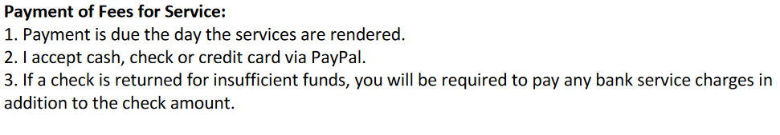
__________________________
Client’s Name Printed
__________________________ ___________
Client Signature Date

Well-Being Assessment
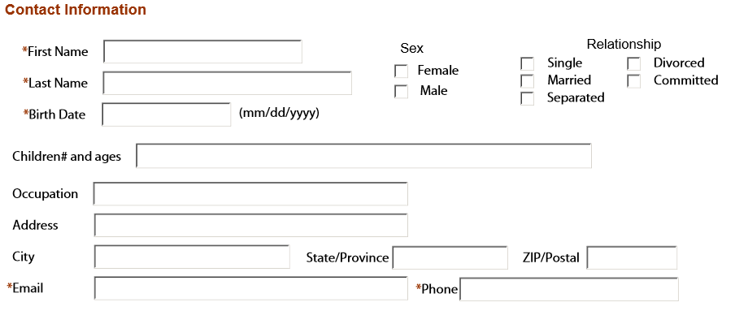
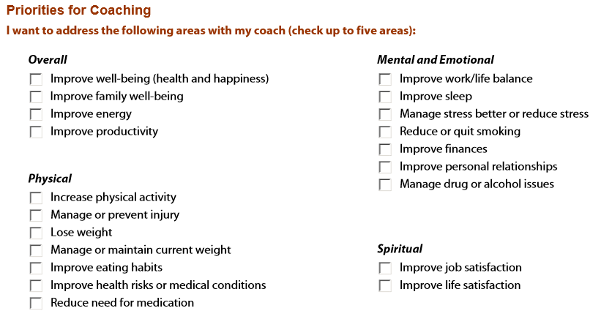
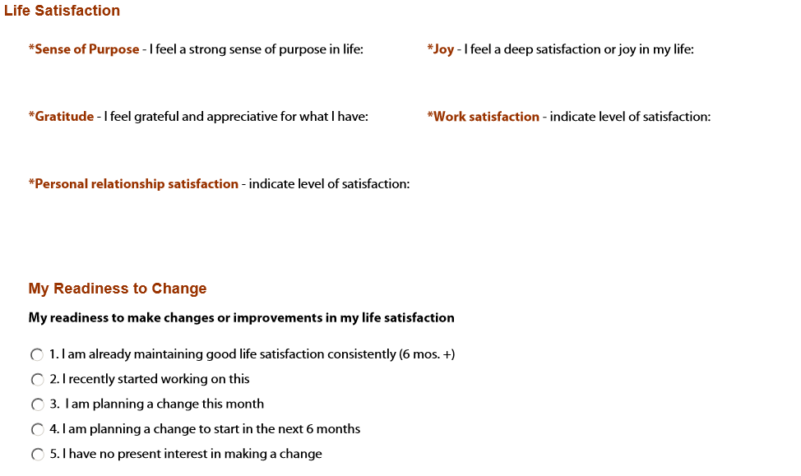
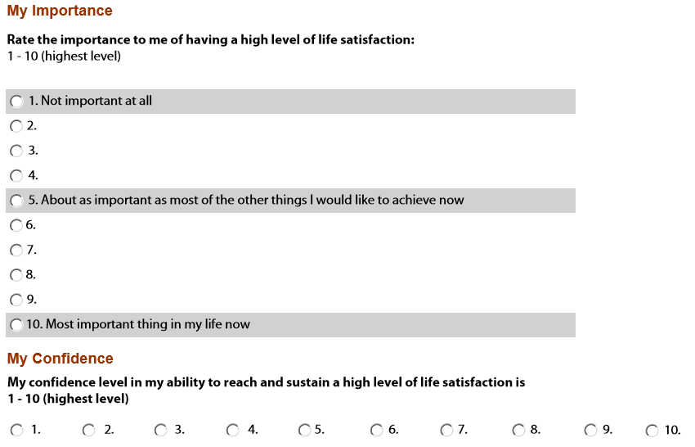
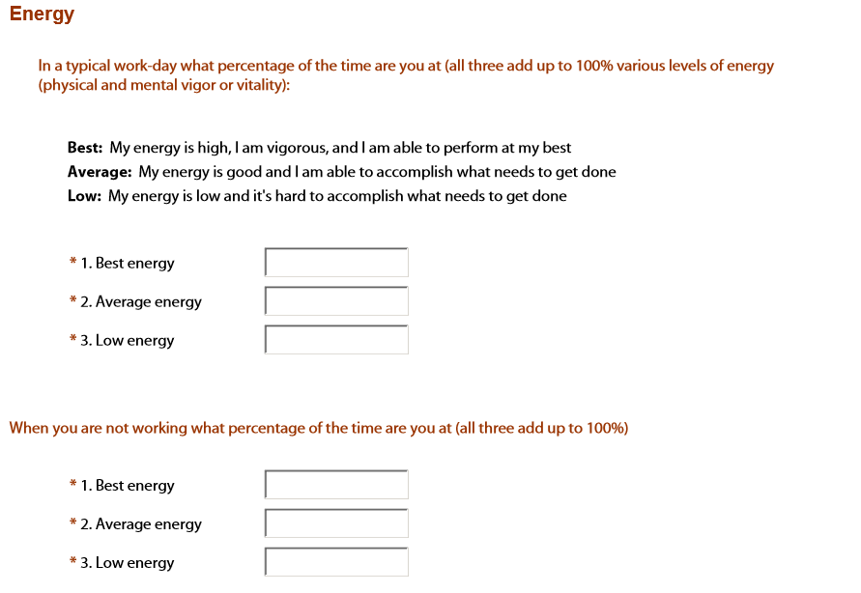
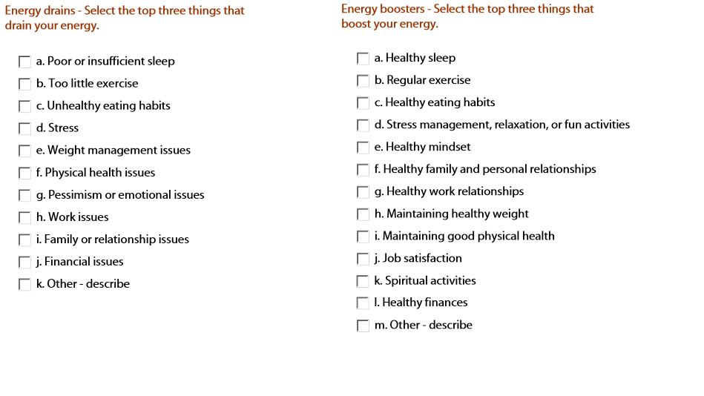
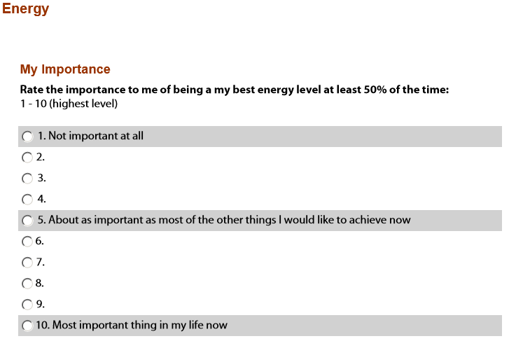
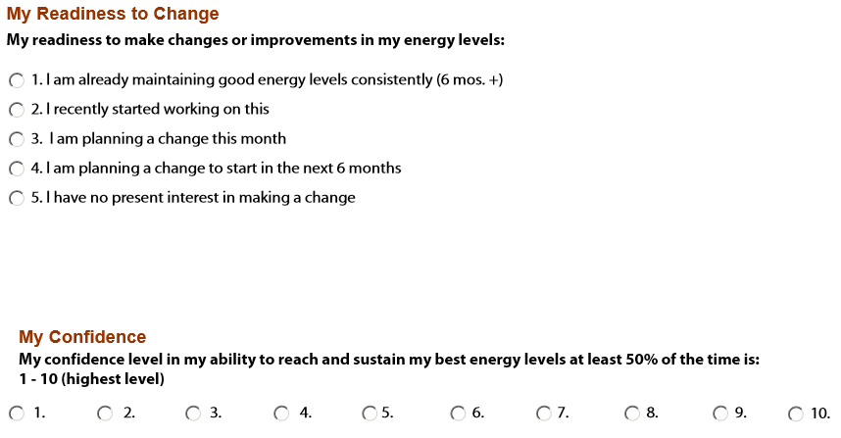
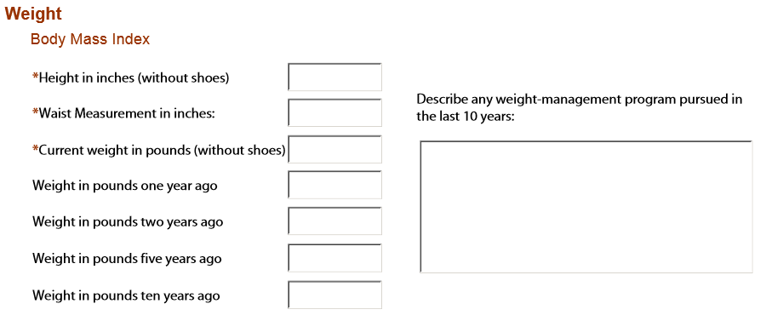
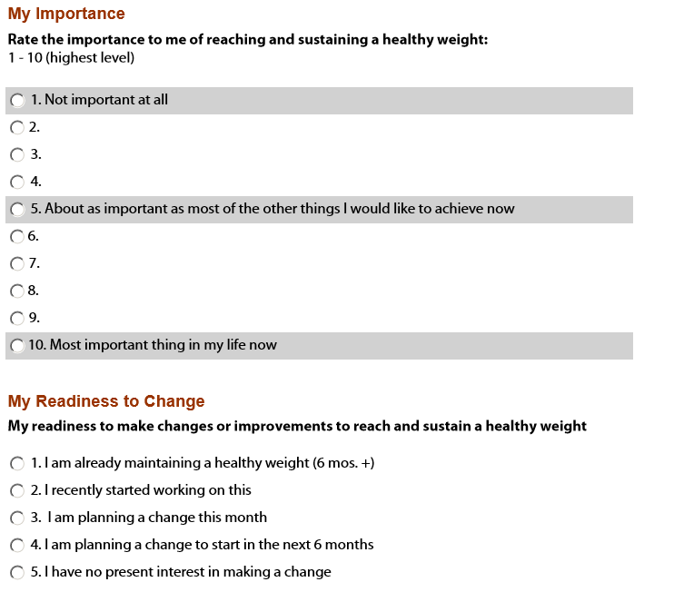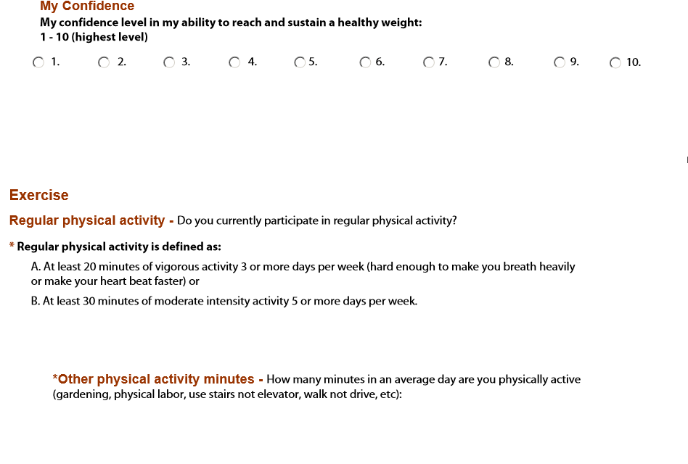
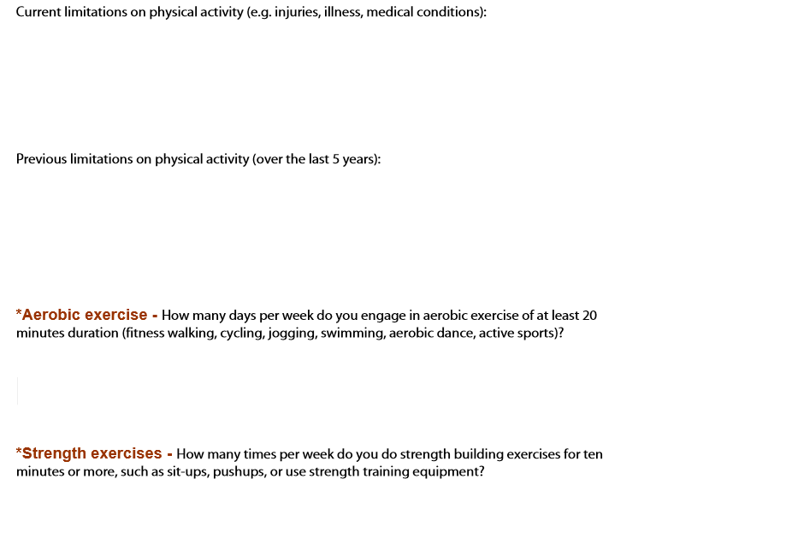
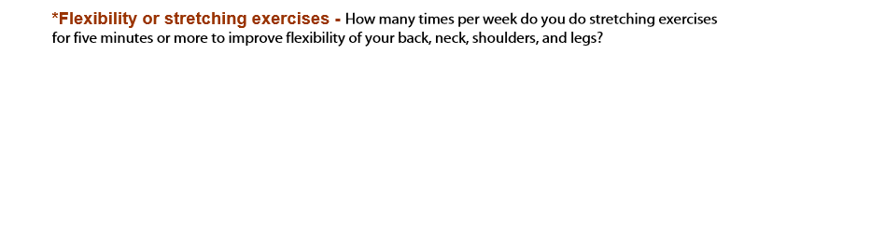
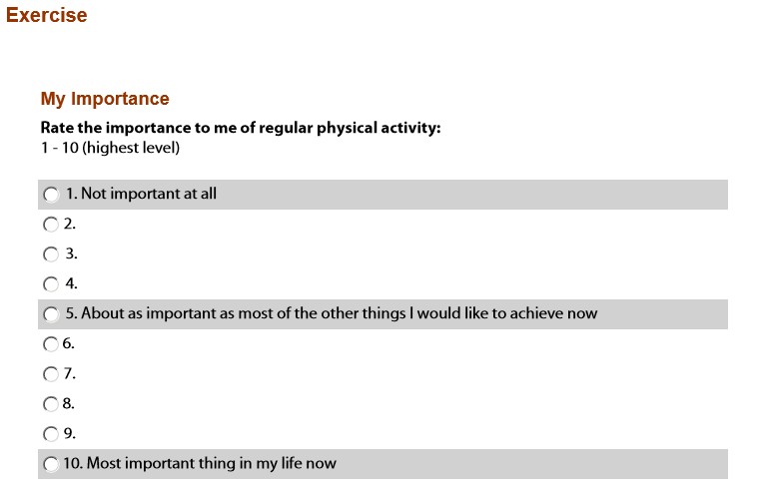
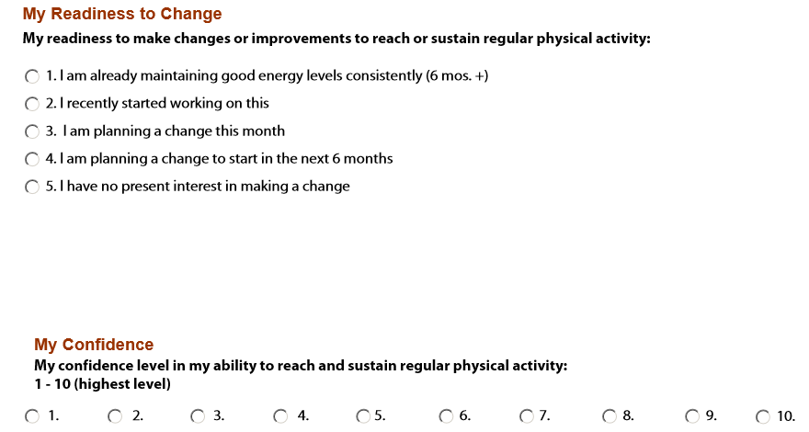
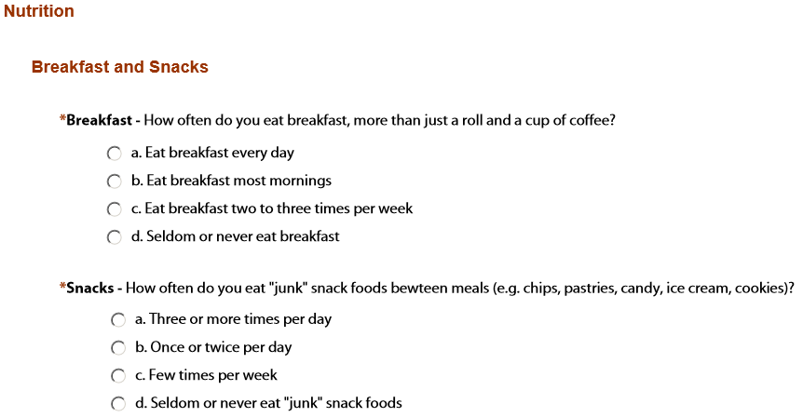
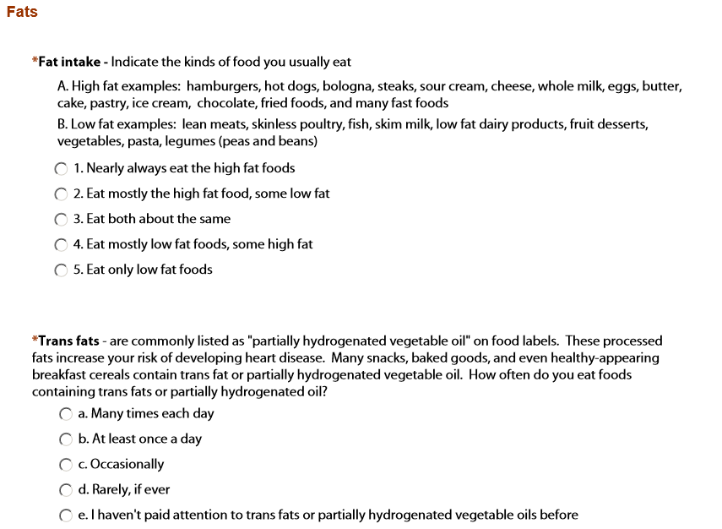
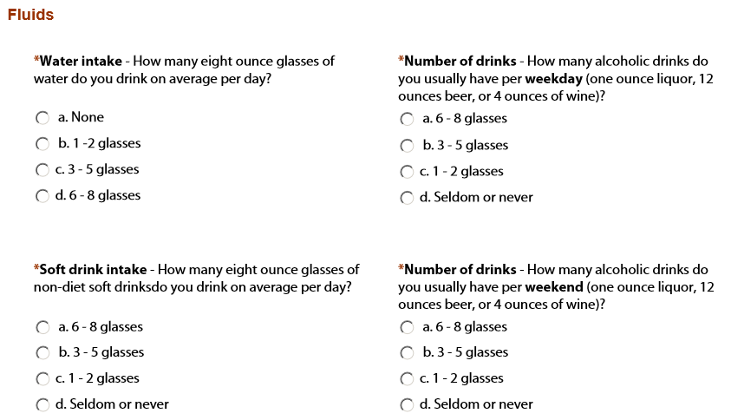
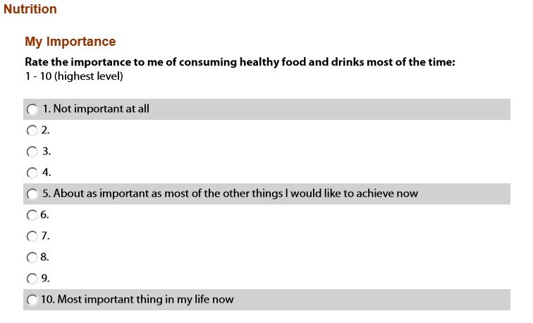
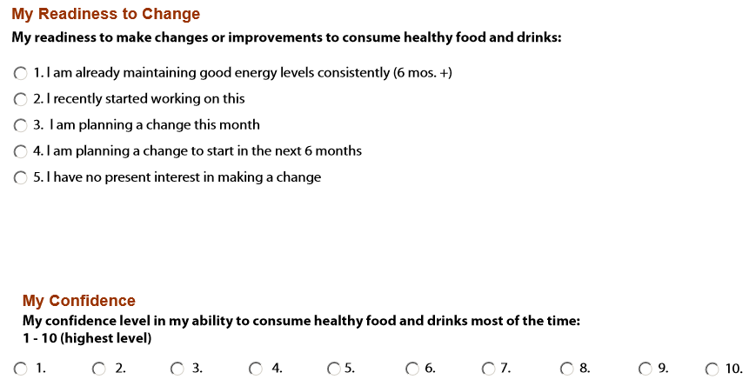
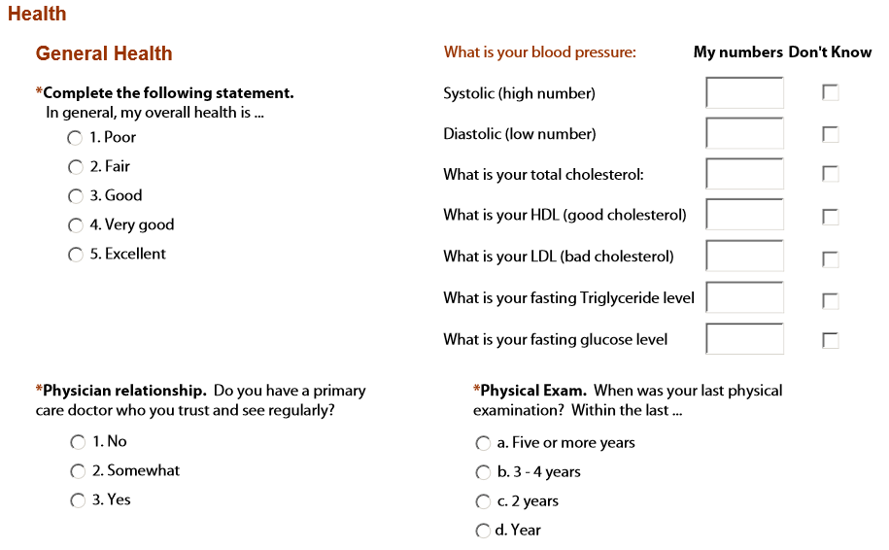
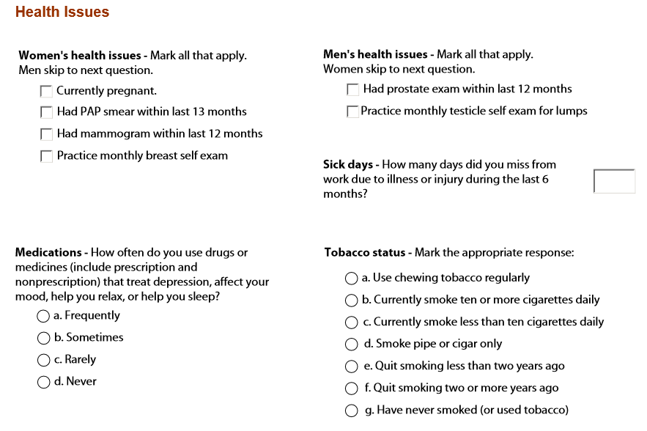
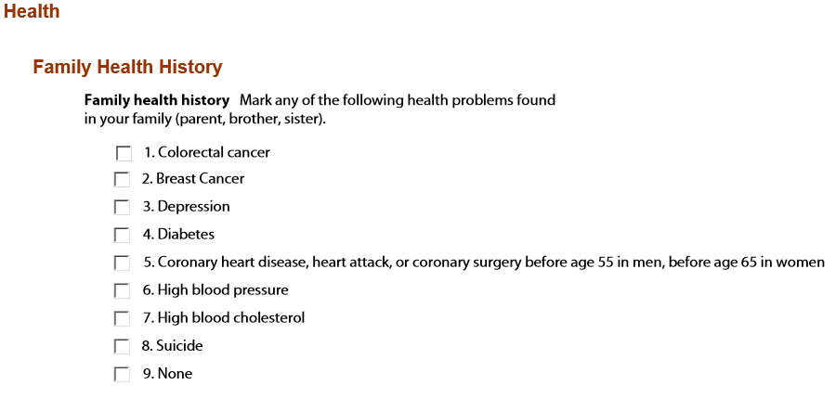
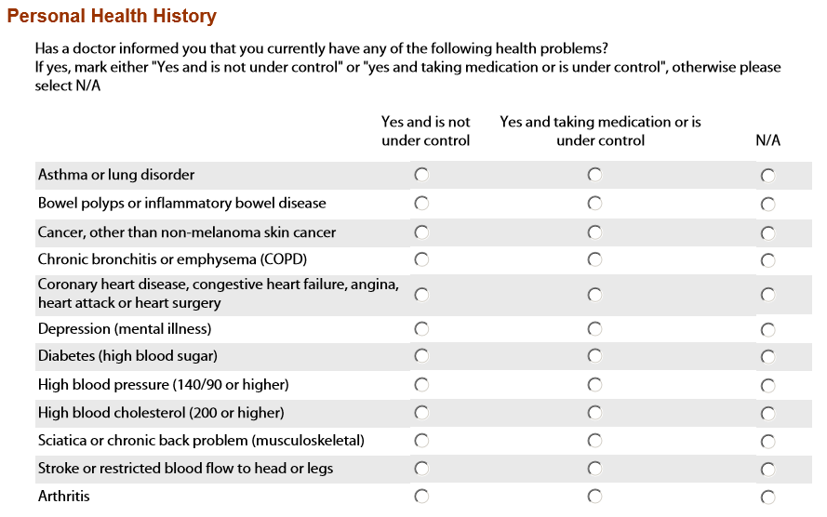
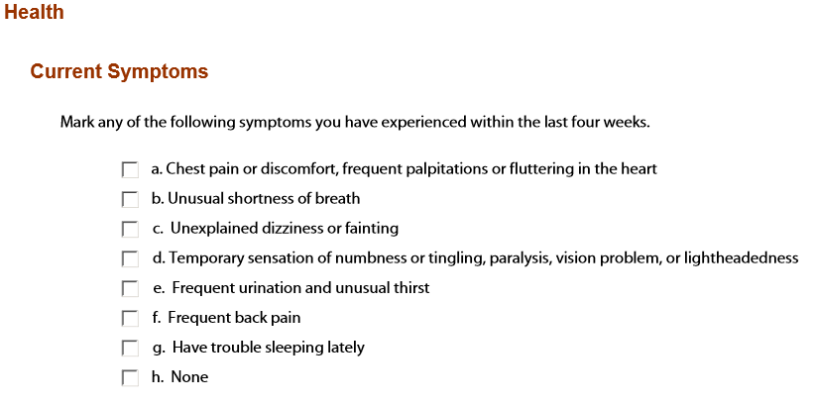
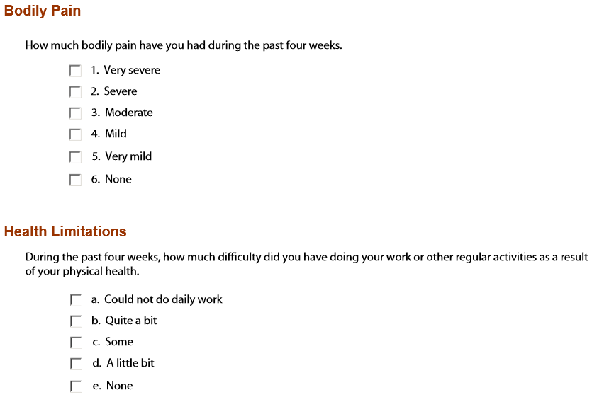
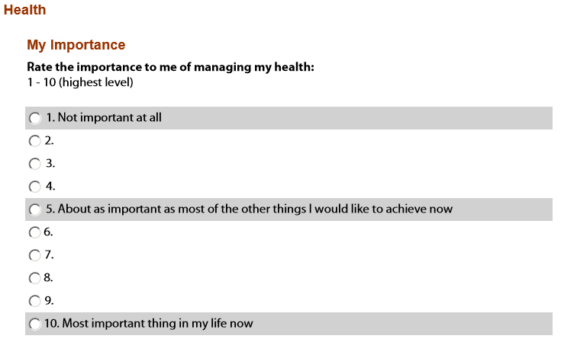
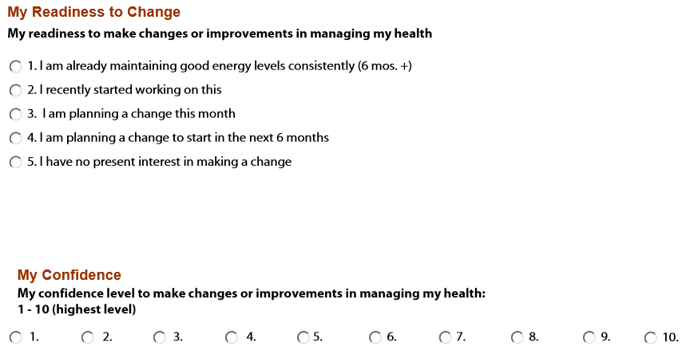
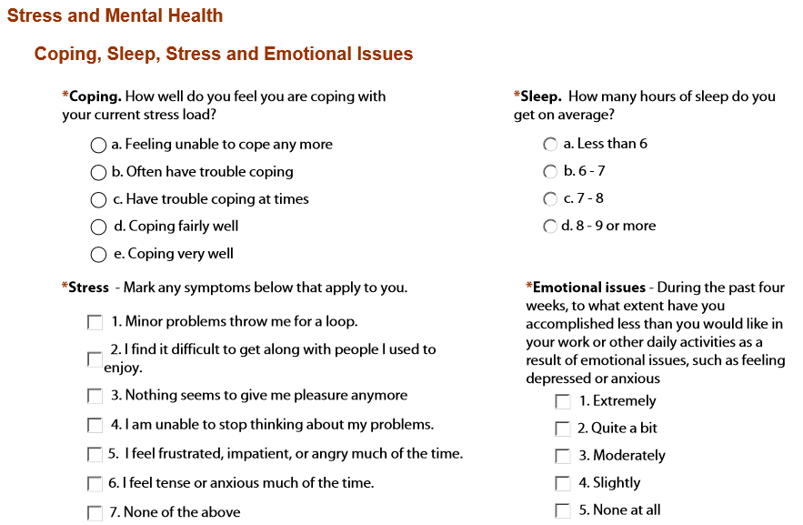
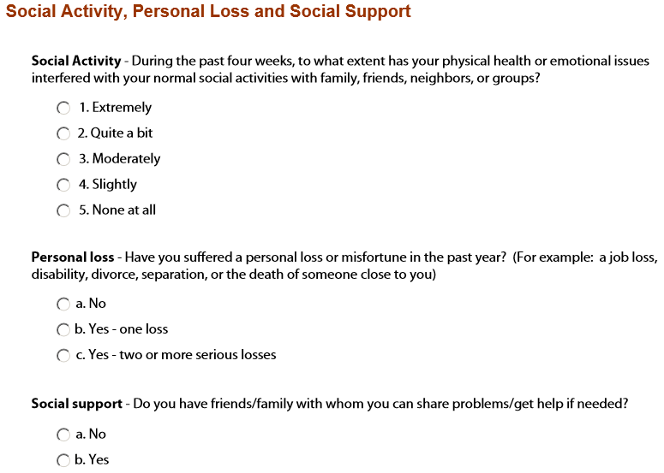
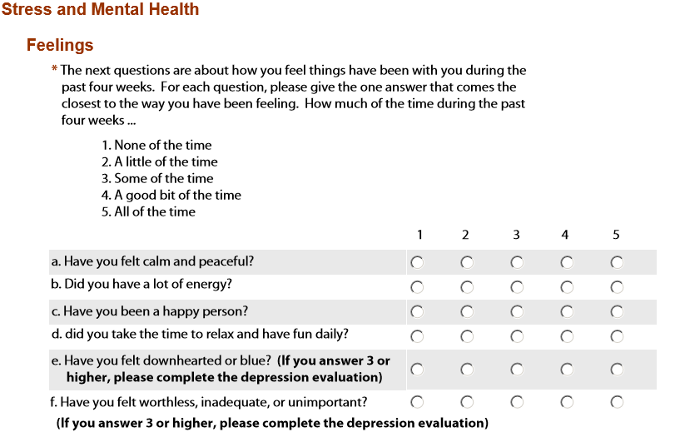
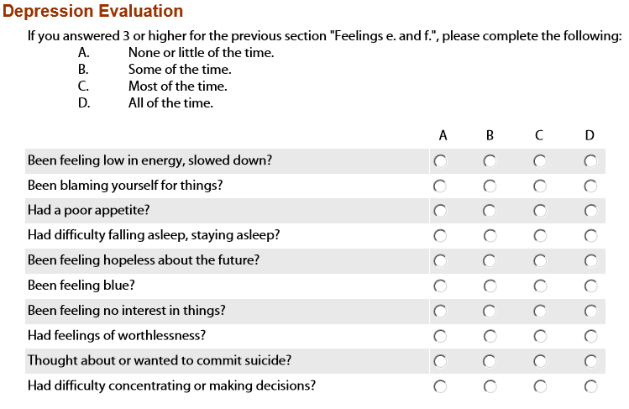
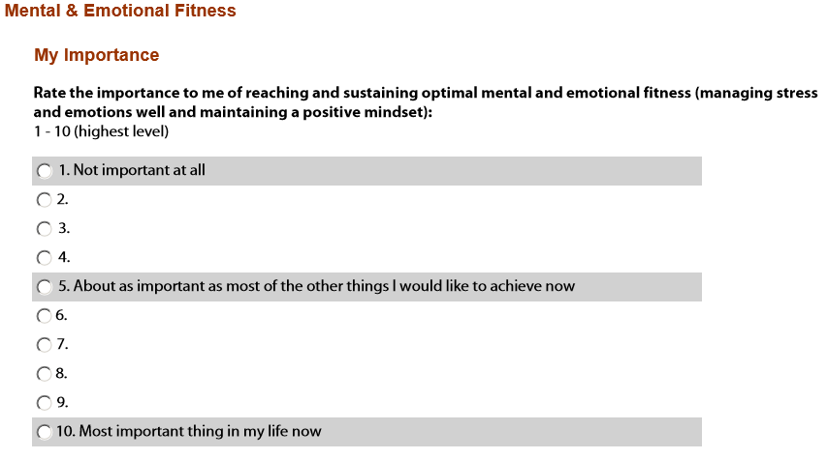
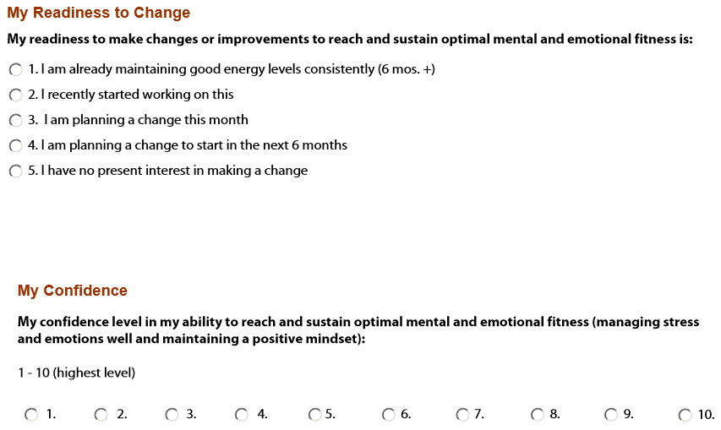

- What is going well? What is not?

2. Please list the challenges and problems you are currently facing in your life and career.

3. Of all these challenges / problems, which need attention immediately?

4. Which are low priority that can be corrected over time?

5. Where would you like to see yourself (in life, relationships, work, career) in 5 years?

6. Does this 5-year vision feel easy to accomplish or will it require major steps to manifest?

7. What are the 10 goals you want to accomplish in the next ninety days?

8. What motivates you to take action? What obstacles to action do you need to anticipate?

What else should Stephanie know about you, as your coach? How can she best support you with coaching (i.e. strong feedback, encouragement, listening, direct suggestions, advice, accountability, other)?

*Adapted from the Wellcoaches Corporation document.

