
Paperwork to Be Completed For & Submitted TO
Stephanie Straeter, Ph.D.
Licensed Clinical Psychologist & Certified Health & Wellness Coach
Prior to First Session Via email (by scanning and emailing to StraeterPHD@Gmail.com) or fax to: 866-545-4568
- Please read the Telemedicine Informed Consent pages 3 - 5 and sign & date page 5 (These policies will be discussed in more detail at the beginning of our first appointment)
- Please read the Notice of Privacy Practices & the Notice of Privacy Practices Acknowledgement pages 6 – 8 and sign and date page 8
- Please read and complete information requested in the Client Information (Couples Form), pages 9– 12 and sign and date page 12
- If planning to use insurance to partially cover my services as an out of network provider now or in the future please complete page 13 to the best of your knowledge

Dr. Stephanie V. Straeter, Licensed Psychologist
StraeterPhd@Gmail.com
Mobile: 619-549-1465

Telemedicine Informed Consent:
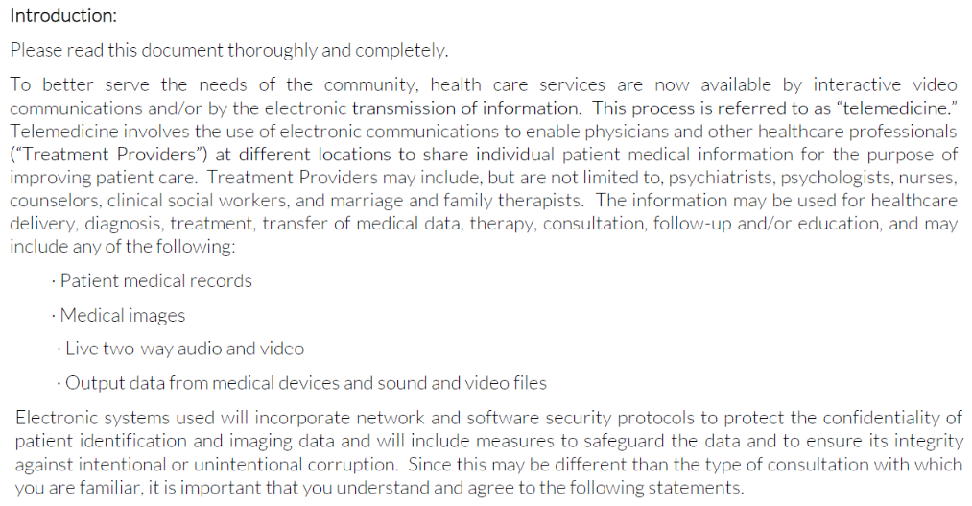
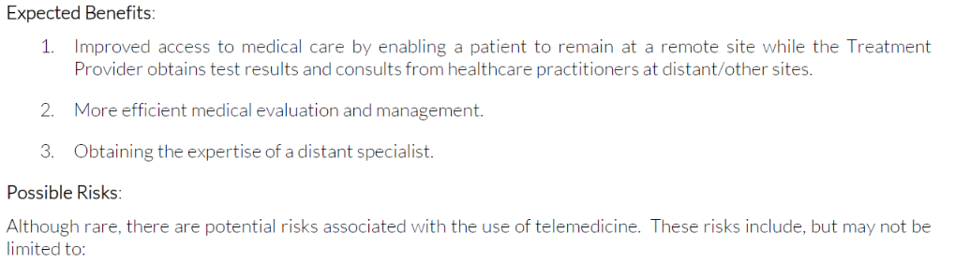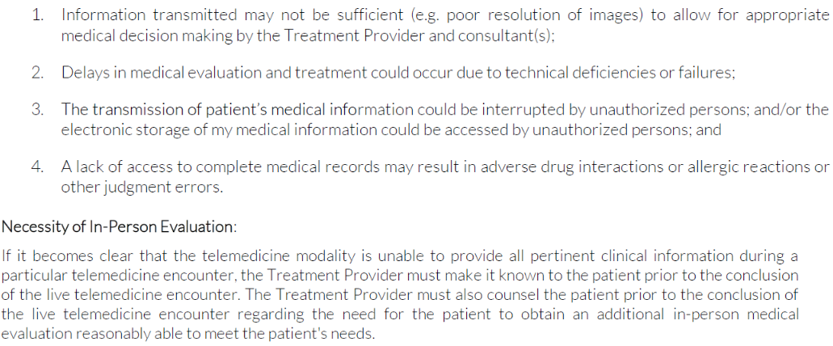
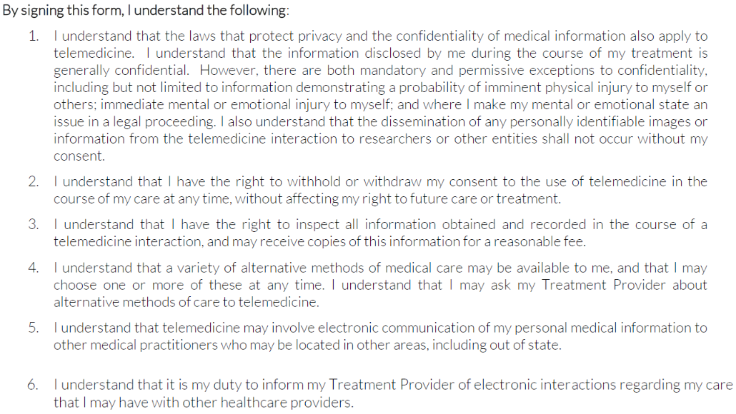
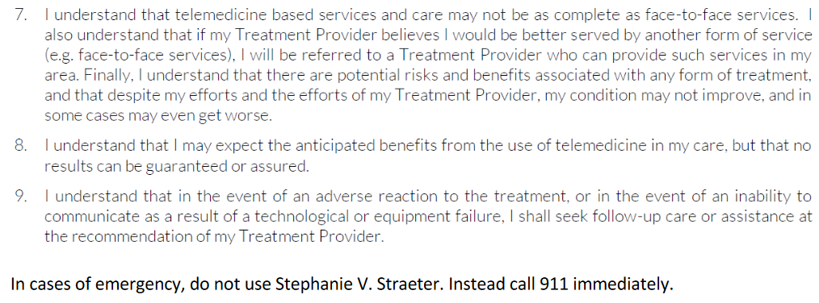
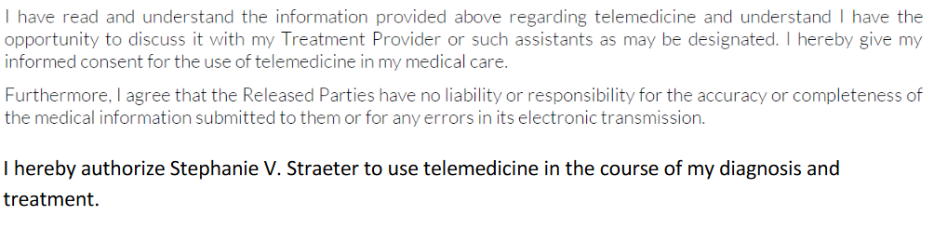
__________________________ ___________
Client Signature Date
__________________________ ___________
Client Signature Date

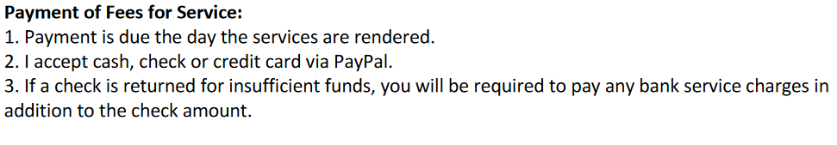
__________________________ ___________
Client Signature Date
__________________________ ___________
Client Signature Date
Dr. Stephanie V. Straeter, Licensed Psychologist
StraeterPhd@Gmail.com
Mobile: 619-549-1465

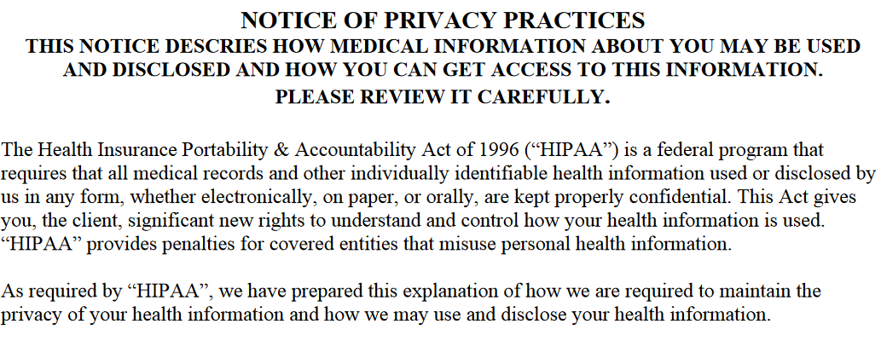
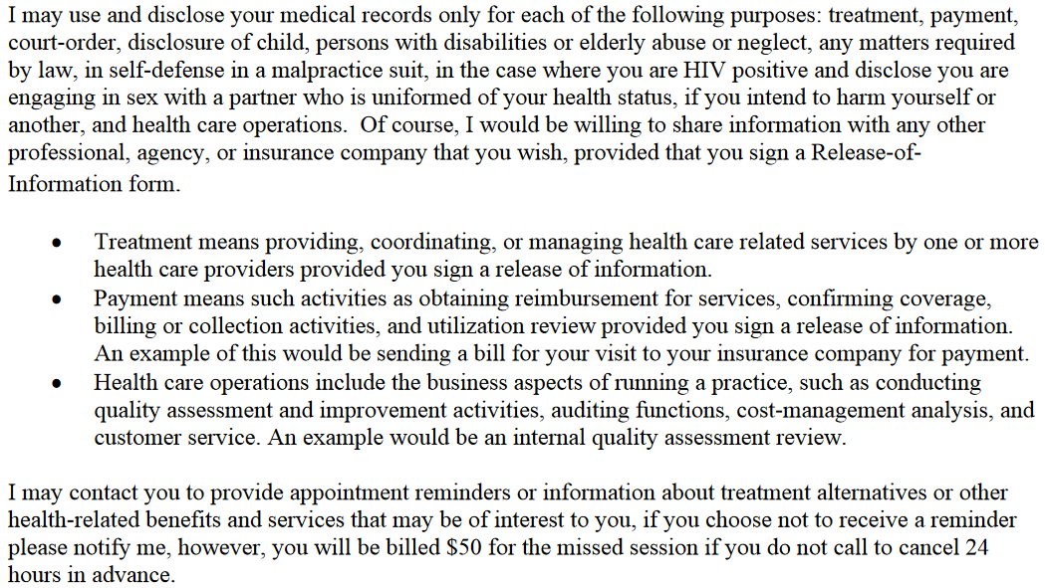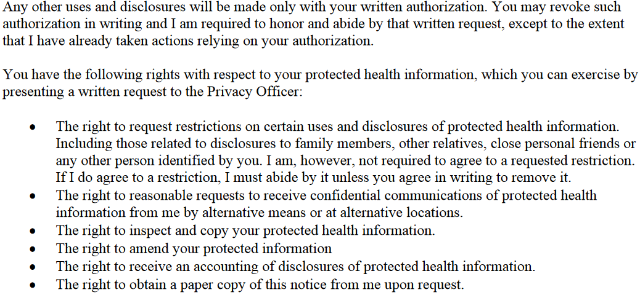

Dr. Stephanie V. Straeter, Licensed Psychologist
StraeterPhd@Gmail.com
Mobile: 619-549-1465

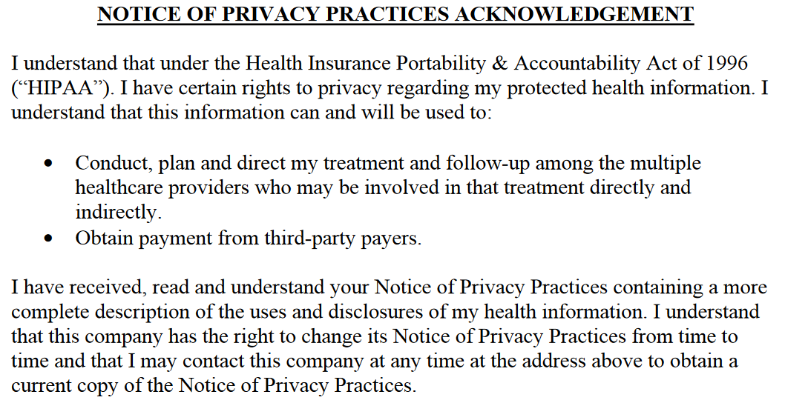
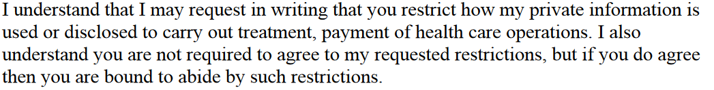

__________________________ _____________
Client Signature Date
__________________________ _____________
Client Signature Date

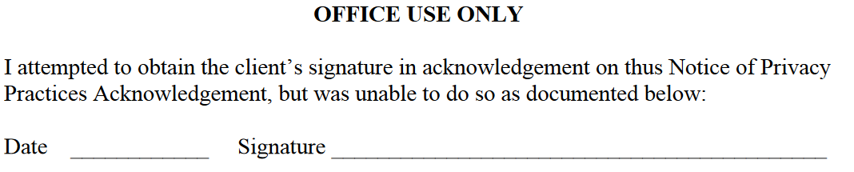
Client Information (Couples Form)
Welcome! Thank you for selecting the private practice of Dr. Stephanie Straeter, Licensed Psychologist. Please complete this form in ink. All information will be kept strictly confidential.
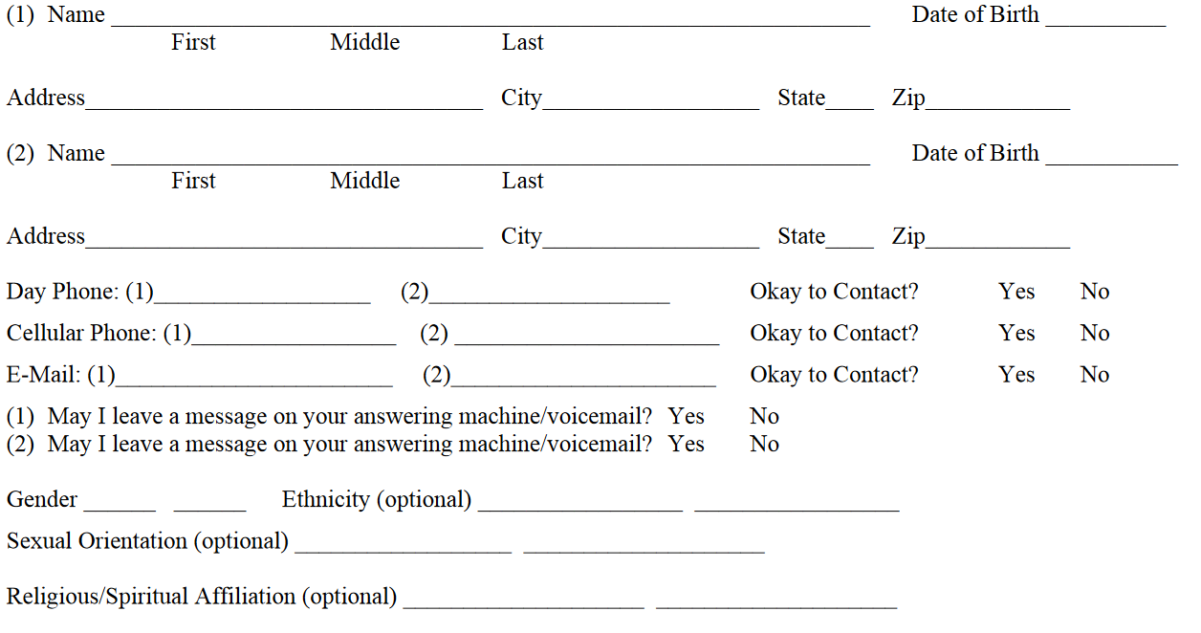
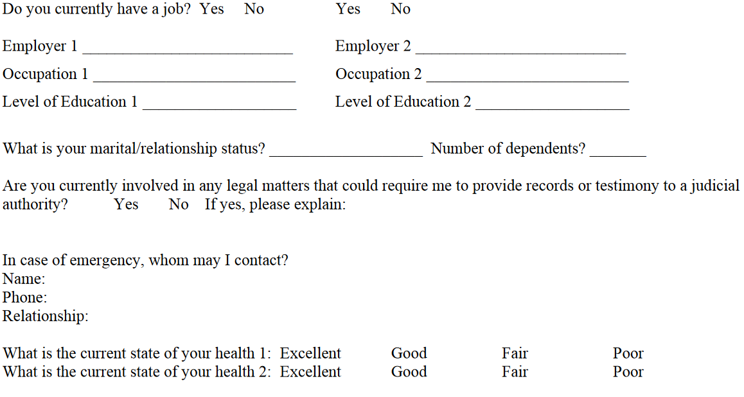
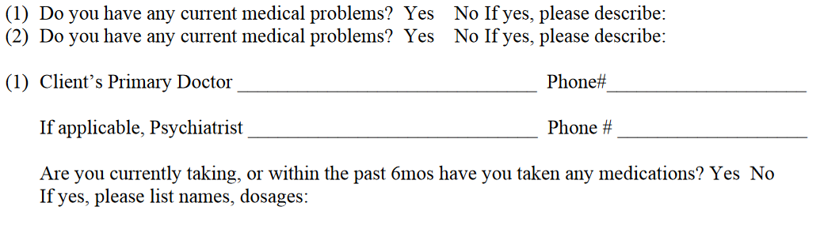
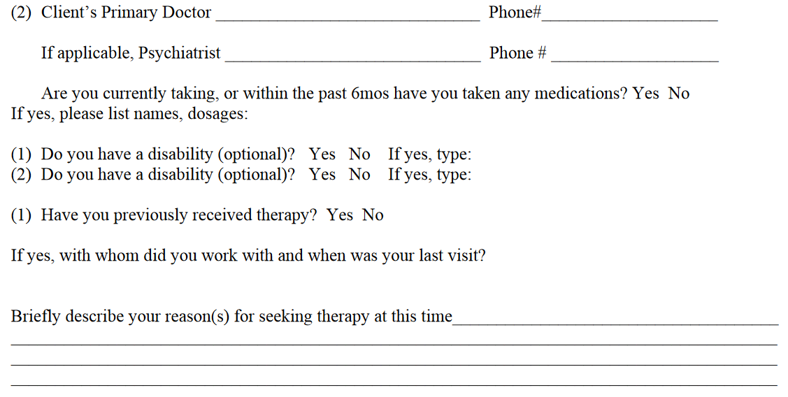
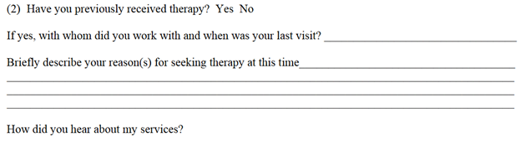
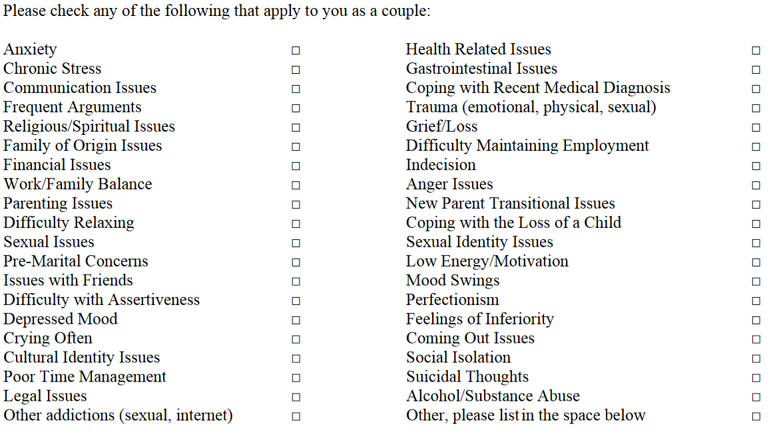

We certify that all information on the Client Information (Couples Form) is true and correct to the best of our knowledge. I will notify Stephanie V. Straeter, Ph.D. of any changes to my address, telephone numbers and any other relevant changes.
__________________________ _____________
Client Signature Date
__________________________ _____________
Client Signature Date

