Paperwork to Be Completed For & Submitted TO
Stephanie Straeter, Ph.D.
Licensed Clinical Psychologist & Certified Health & Wellness Coach
Prior to First Session Via email (by scanning and Securely emailing to straeterPHD@Gmail.com) or fax to: 866-545-4568
- Please read the Telemedicine Informed Consent pages 3 - 5 and sign & date page 5 (These policies will be discussed in more detail at the beginning of our first appointment)
- Please read the Notice of Privacy Practices pages 6 – 9 and sign and date page 10, the Acknowledgement of Receipt of Notice page
- Please read and complete information requested in the Adult Comprehensive History and Questionnaire Forms, pages 11 – 27 and sign and date page 28
- If planning to use insurance to partially cover my services as an out of network provider now or in the future please complete page 29 to the best of your knowledge

Telemedicine Informed Consent
Stephanie V. Straeter PhD.
FL license PY8570 CA License PSY19872 NY License 022290-1
Straeterphd@gmail.com
Mobile: 619-549-1465

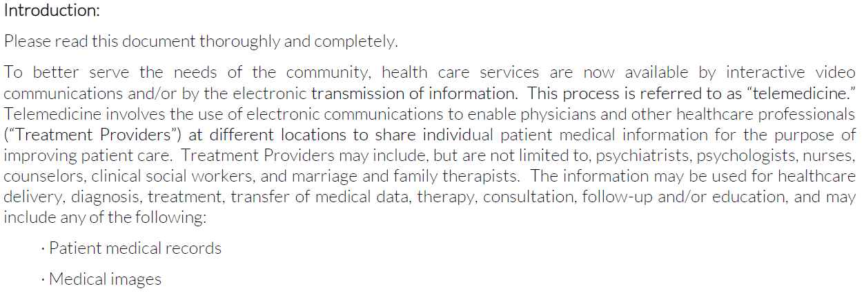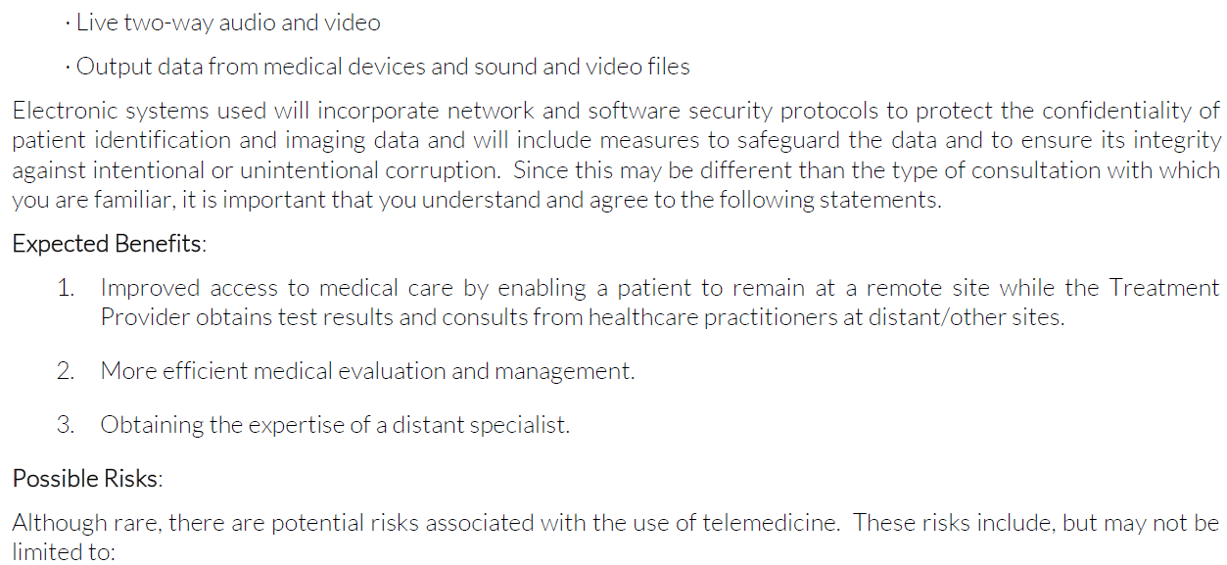
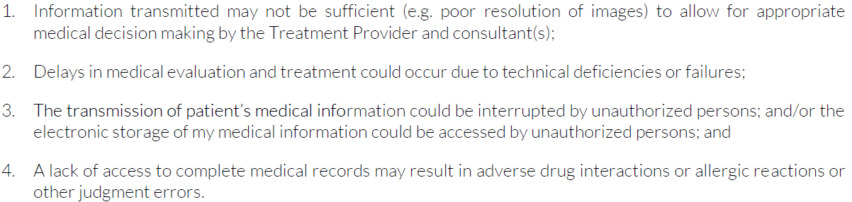
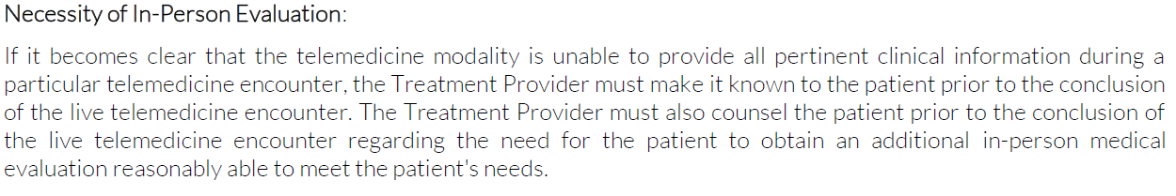
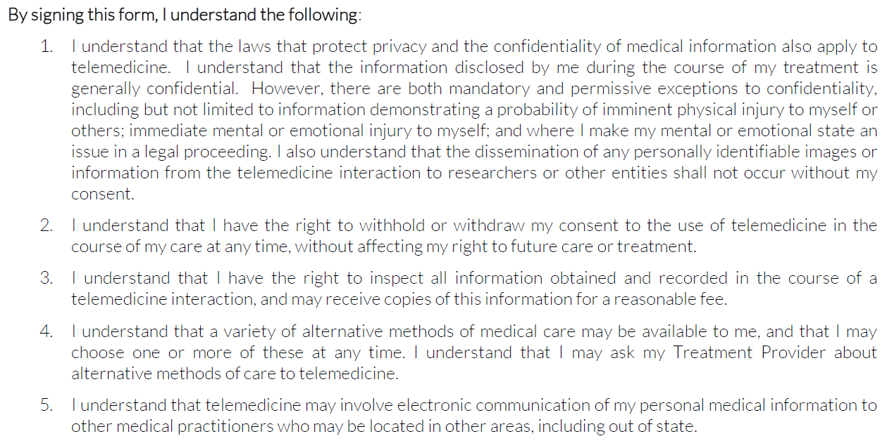
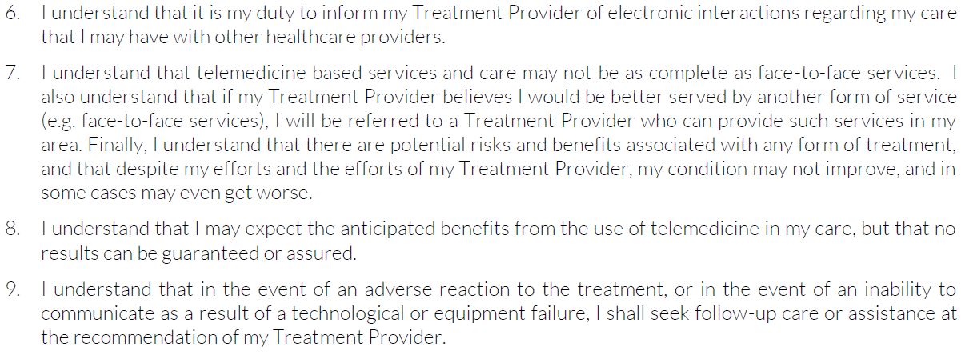
In cases of emergency, do not use Stephanie V. Straeter. Instead call 911 immediately.
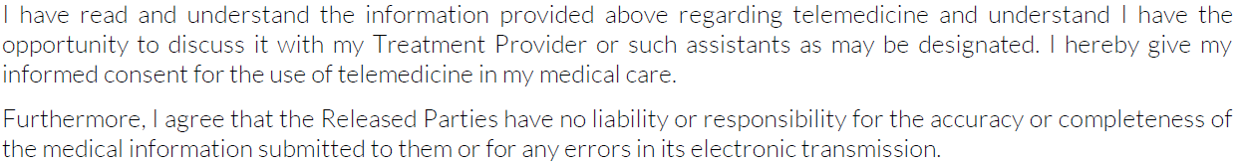
I hereby authorize Stephanie V. Straeter to use telemedicine in the course of my diagnosis and treatment.
_____________________________________________ _______________________
Signature Date

_____________________________________________
Printed Name

All appointments must be changed or cancelled 24 hours in advance to avoid a $75.00 charge.
Payment of Fees for Service:
1. Payment is due the day the services are rendered.
2. I accept cash, check or credit card via PayPal.
3. If a check is returned for insufficient funds, you will be required to pay any bank service charges in addition to the check amount.

_____________________________________________ _______________________
Signature Date

_____________________________________________
Printed Name

Stephanie V. Straeter PhD.
FL license PY8570 CA License PSY19872 NY License 022290-1
Straeterphd@gmail.com
Mobile: 619-549-1465

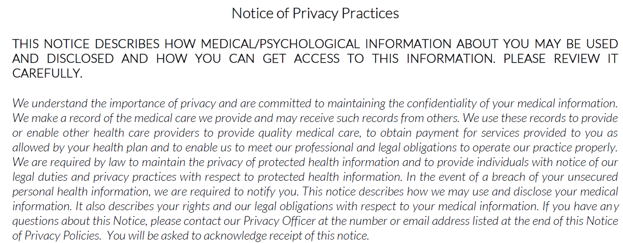
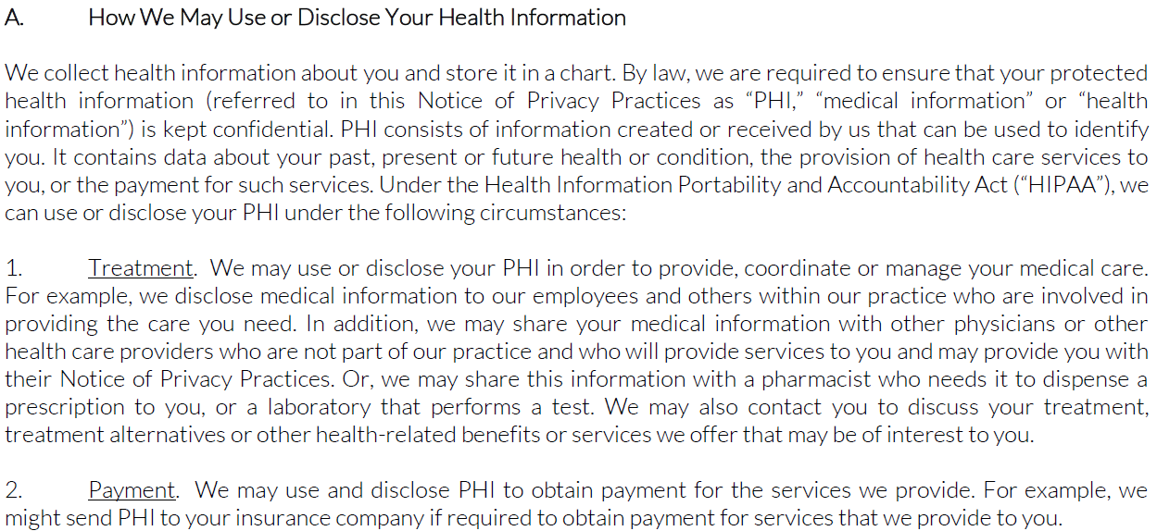
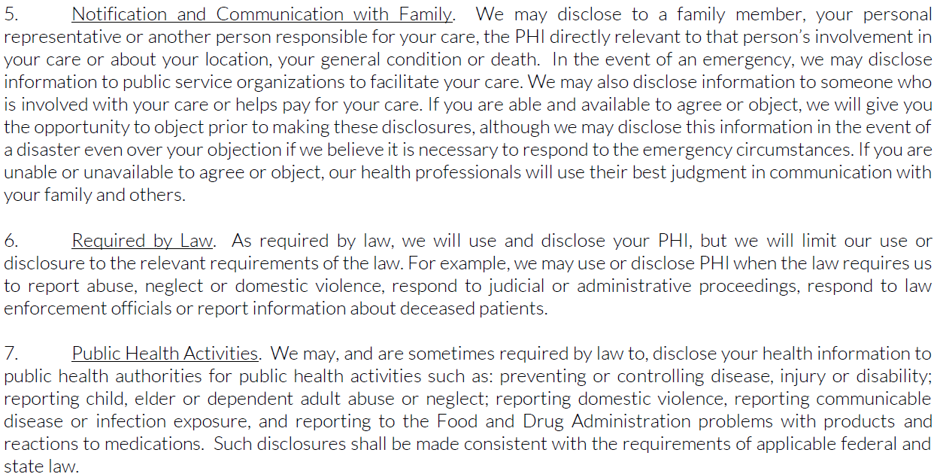
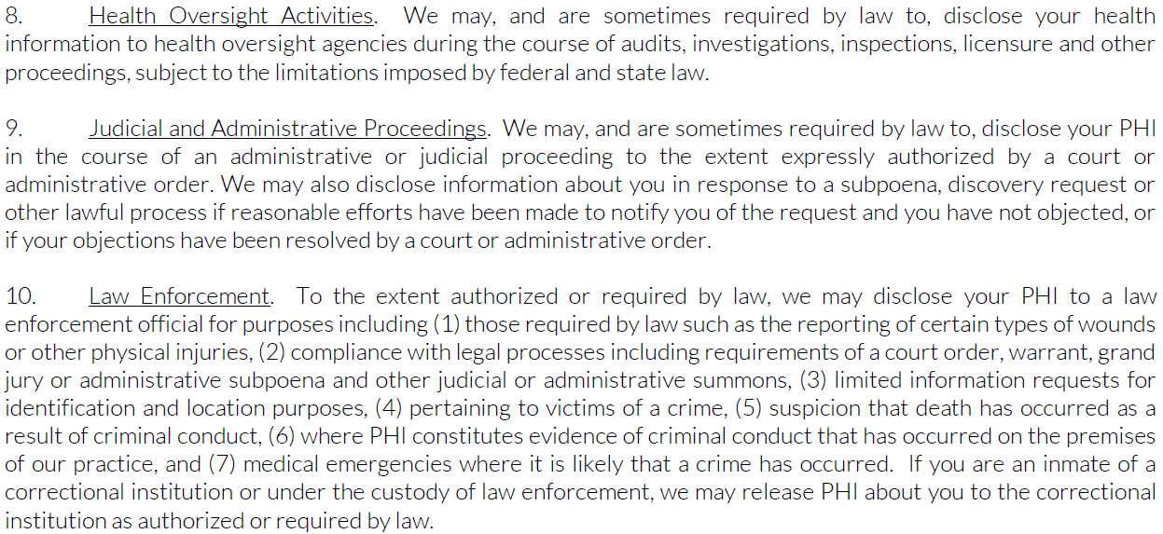
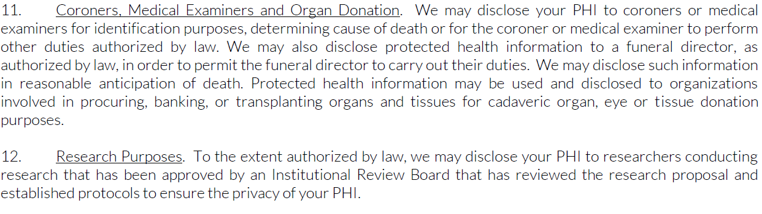
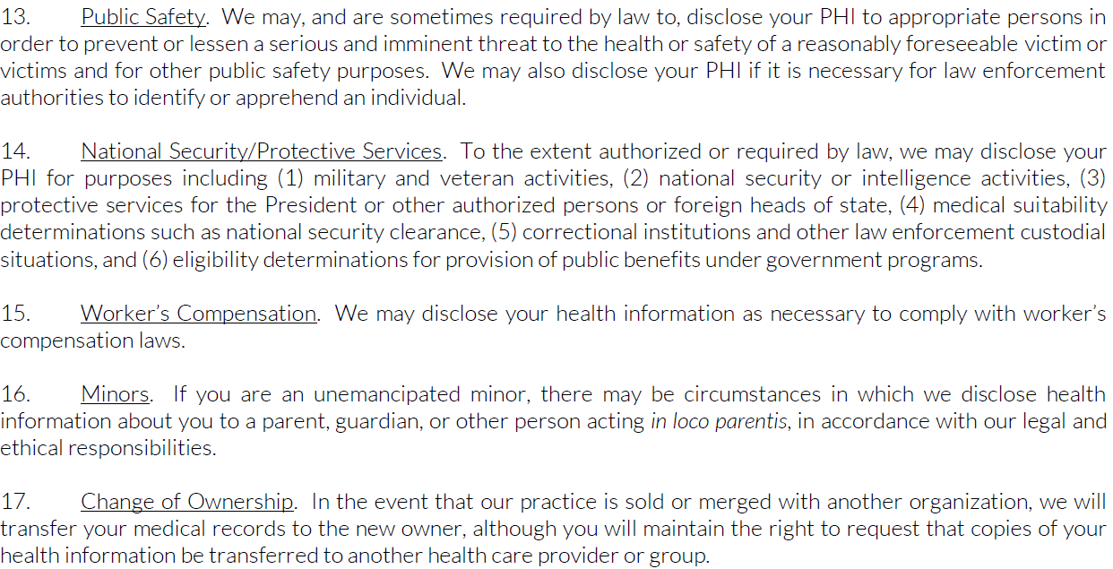
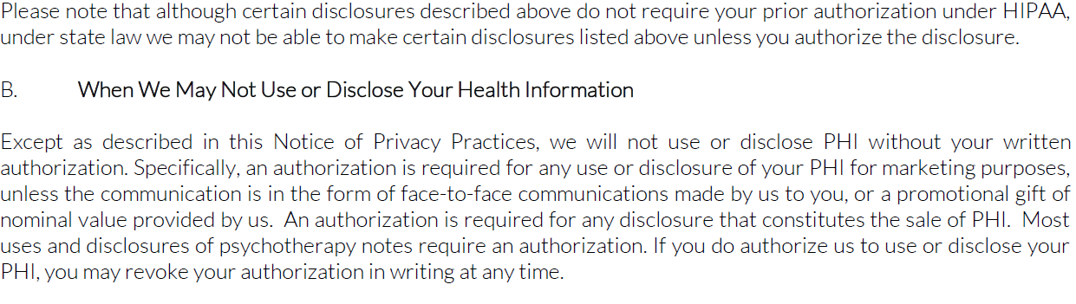
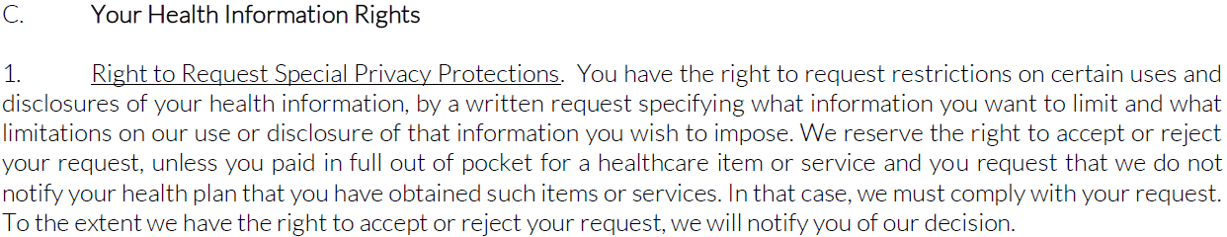
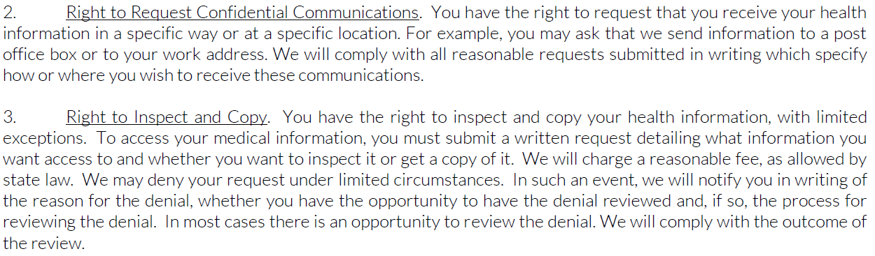

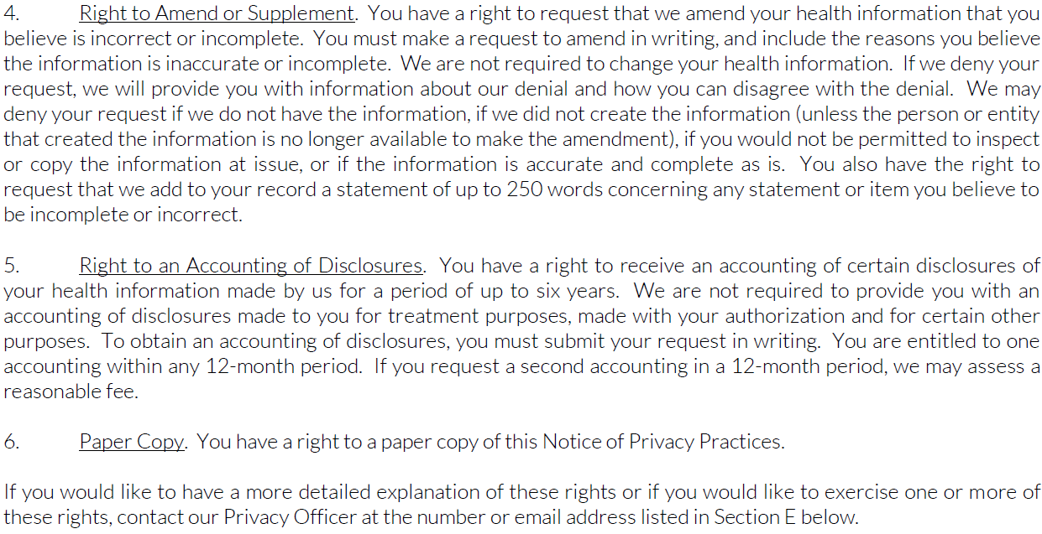
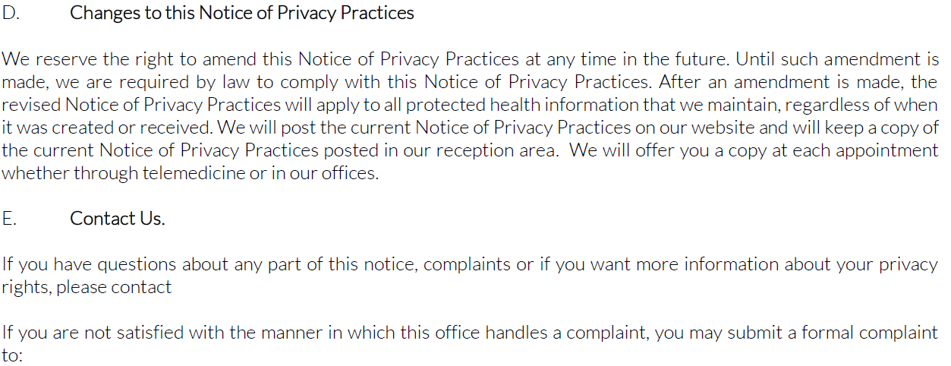
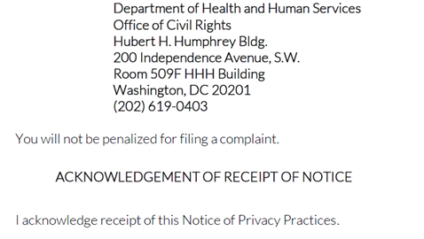

_________________________________________ ___________________________
Signature Date

_________________________________________
Printed Name

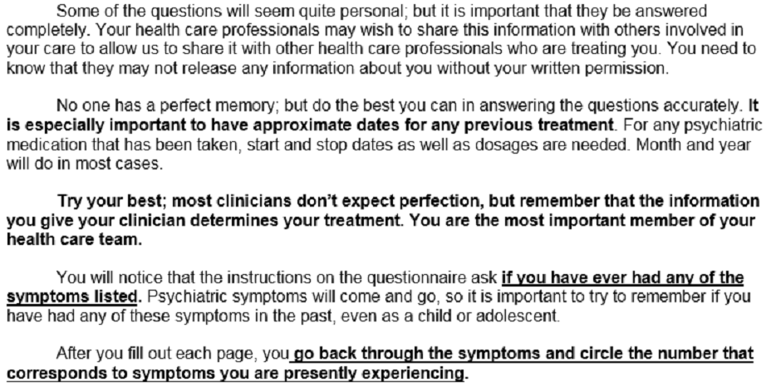
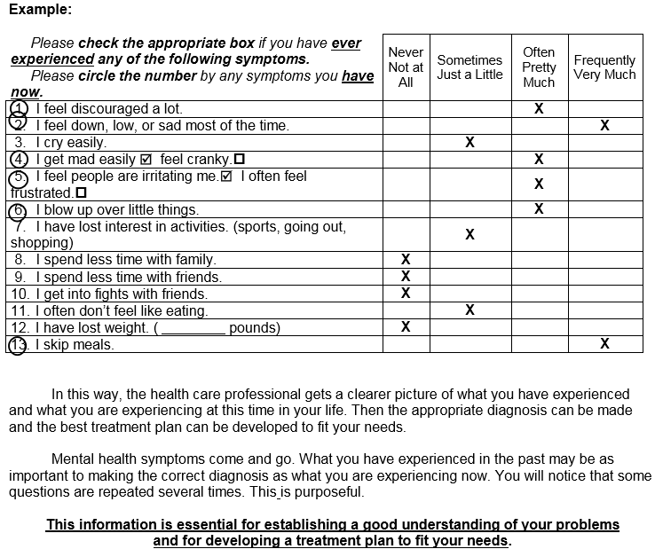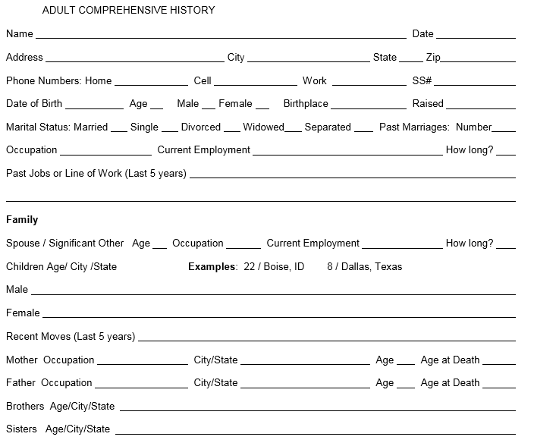
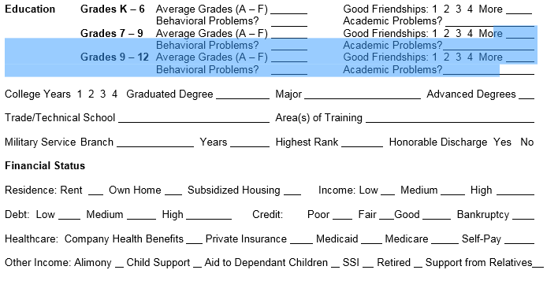
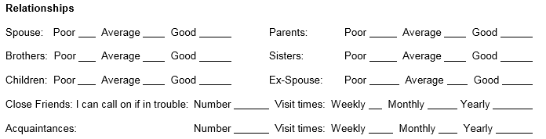
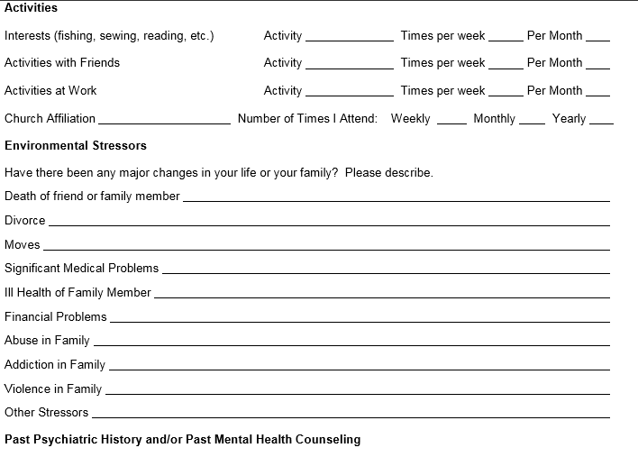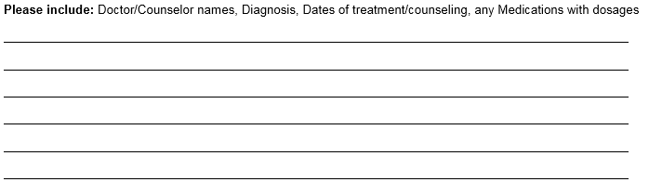
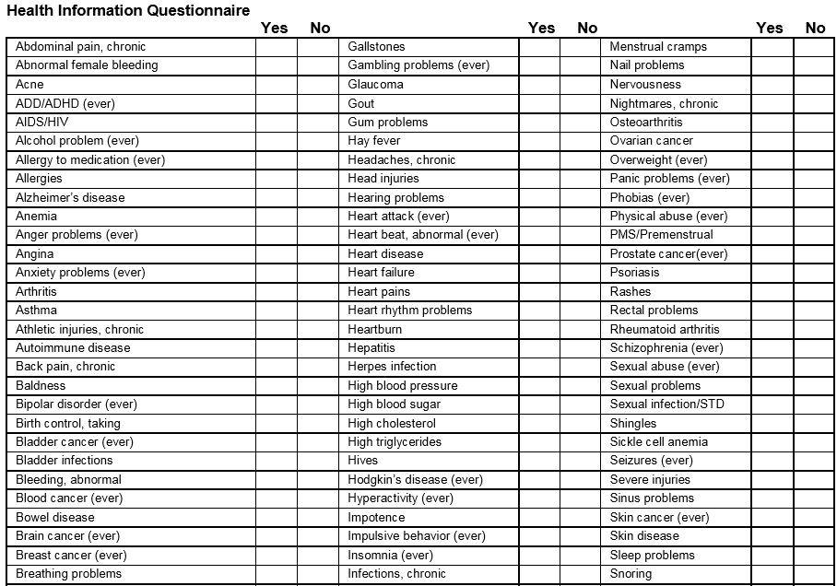
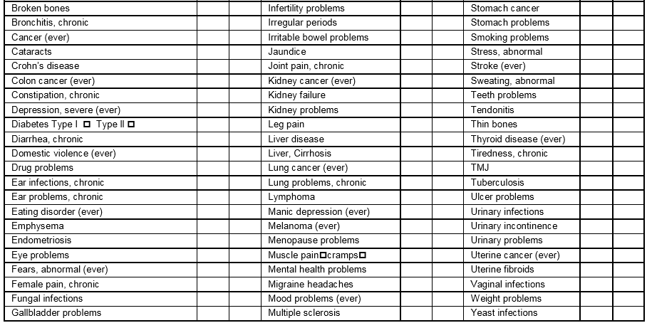
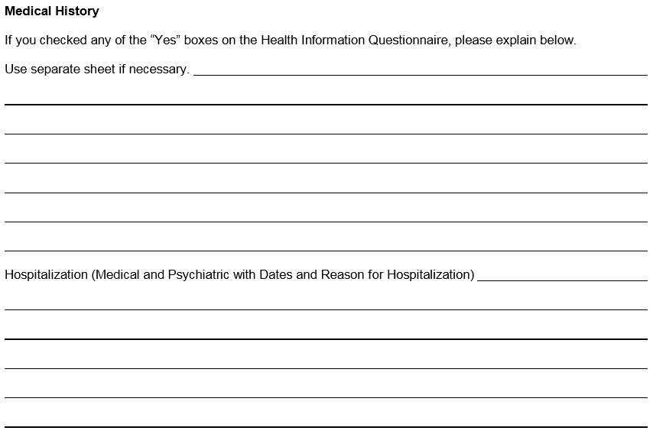
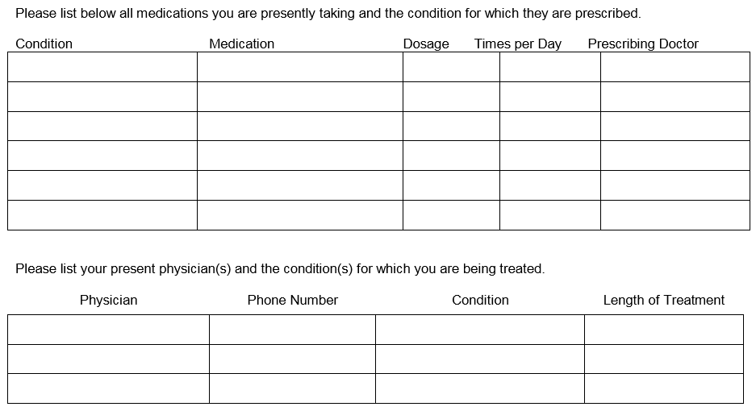
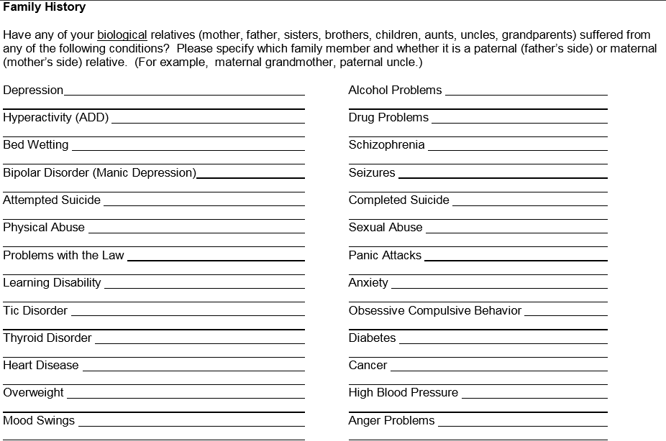
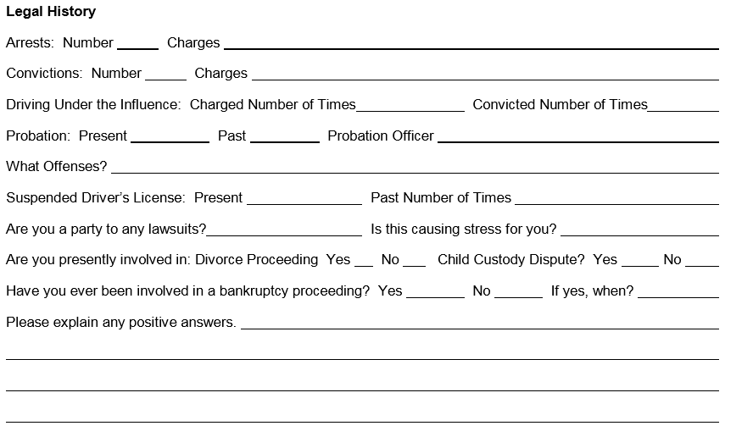
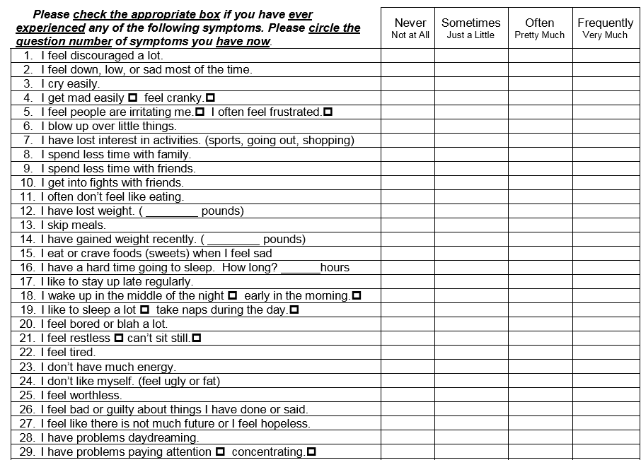
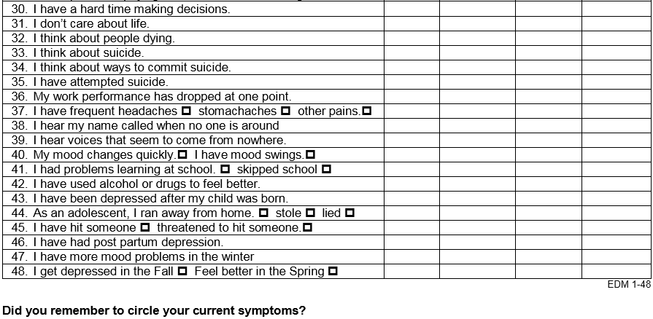
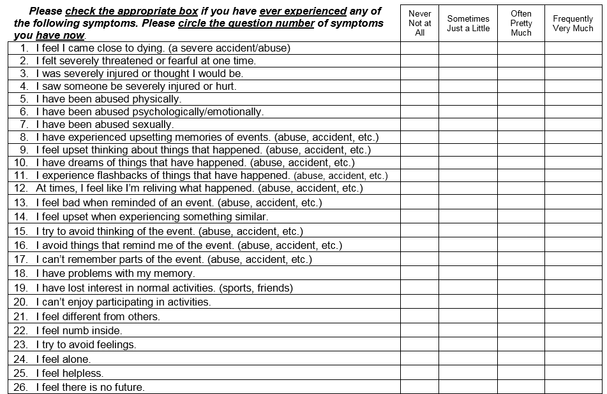
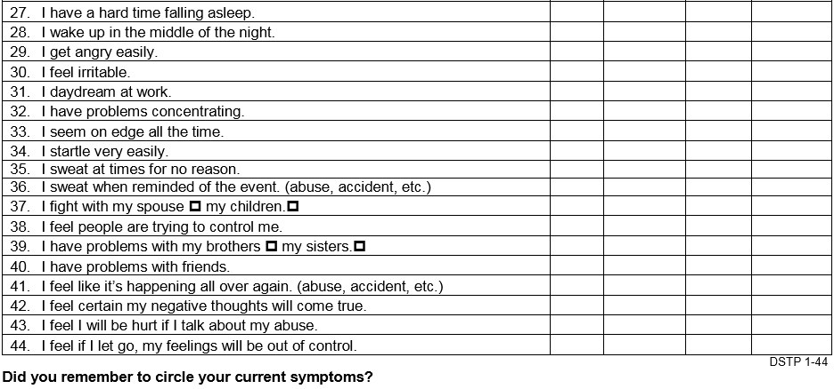

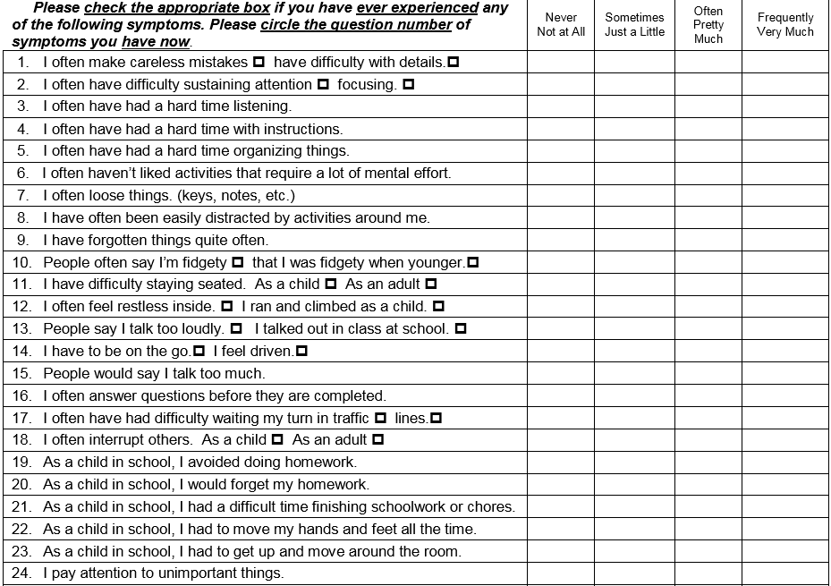
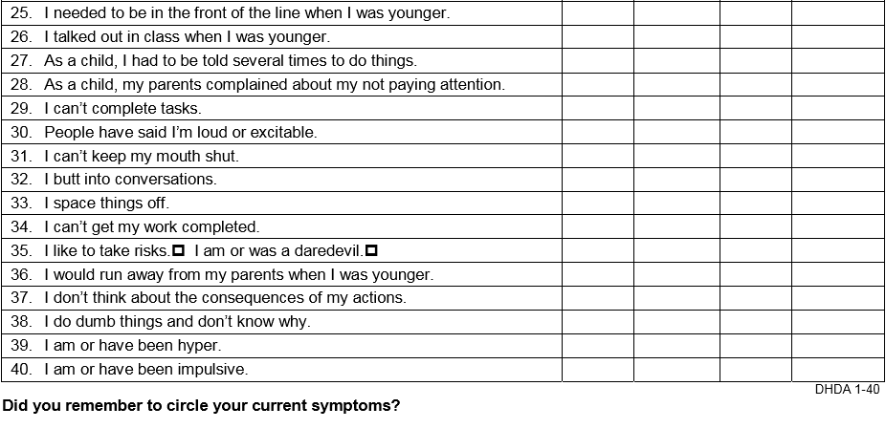
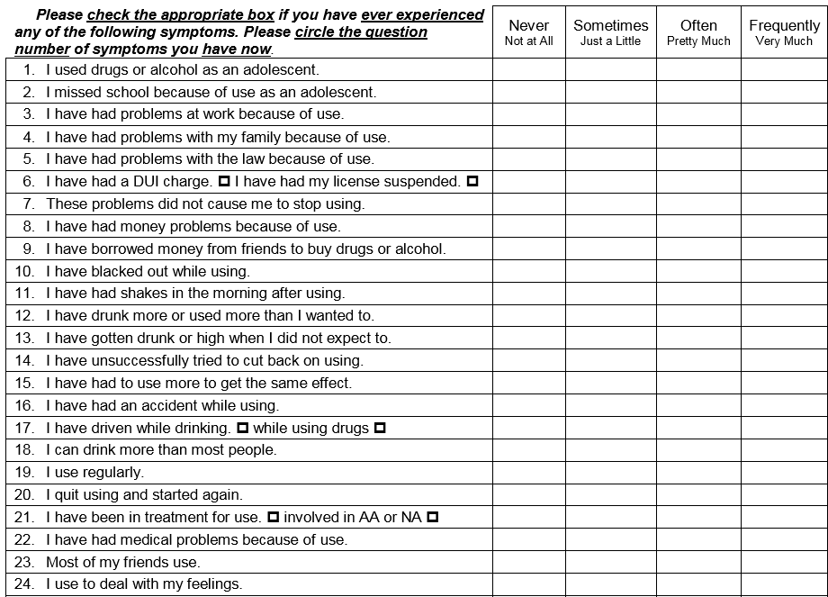
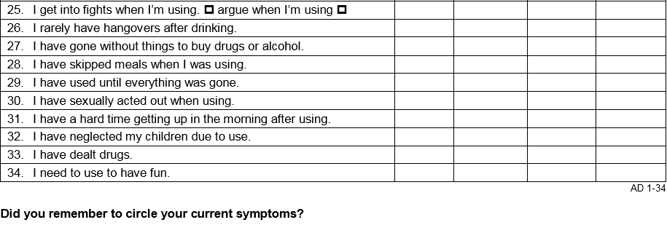
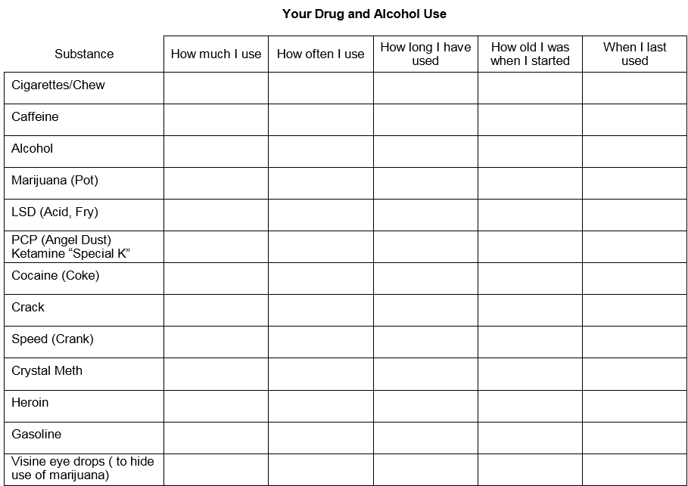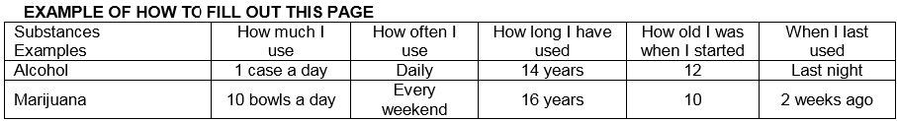
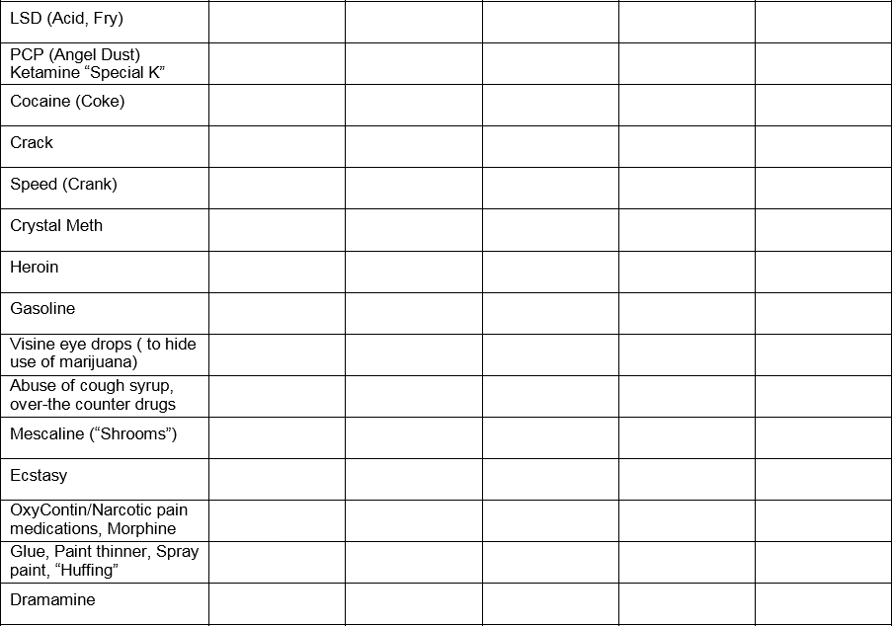
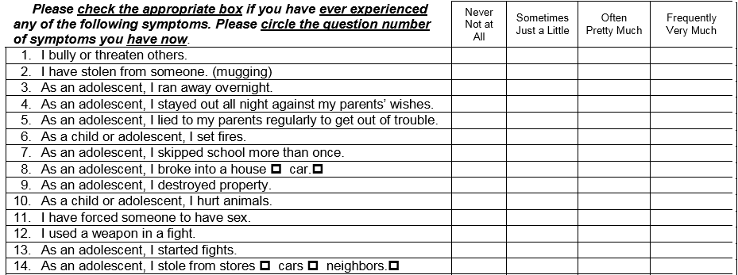
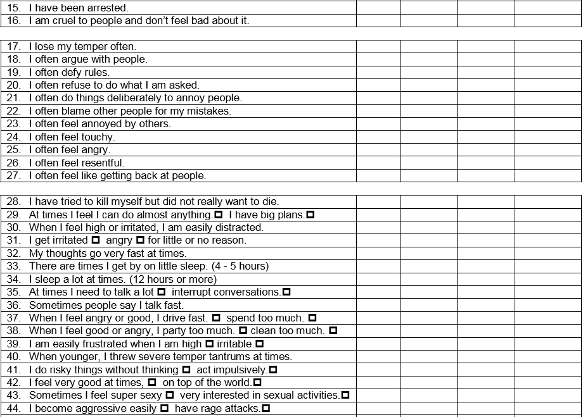
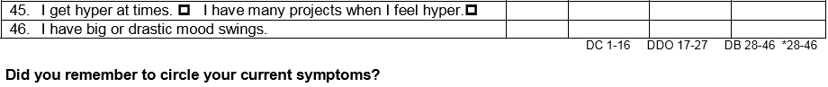
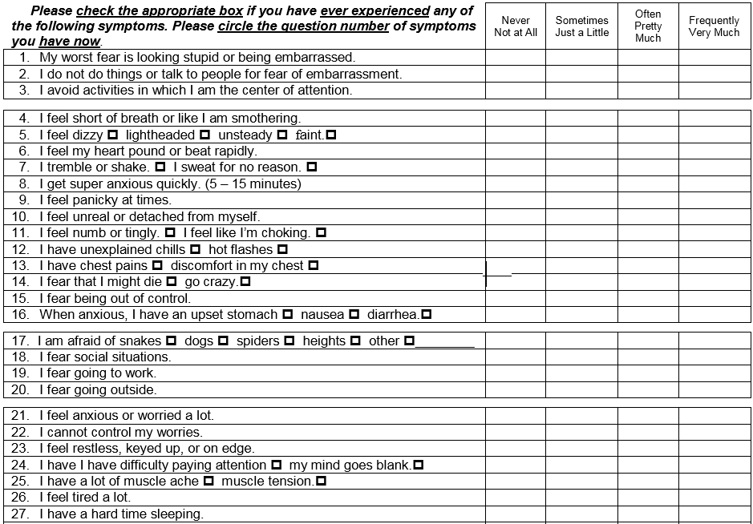
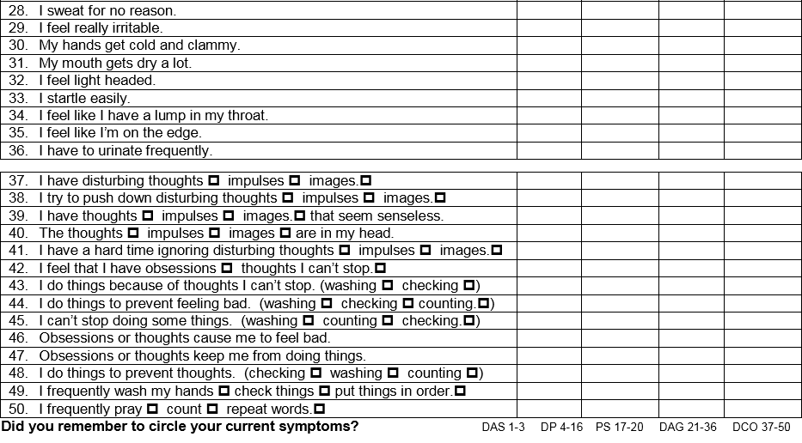
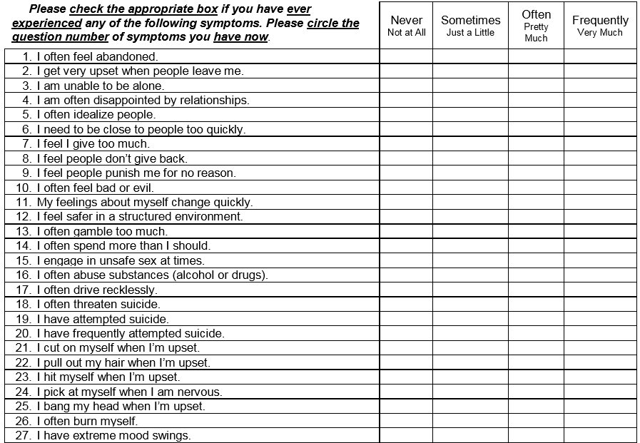
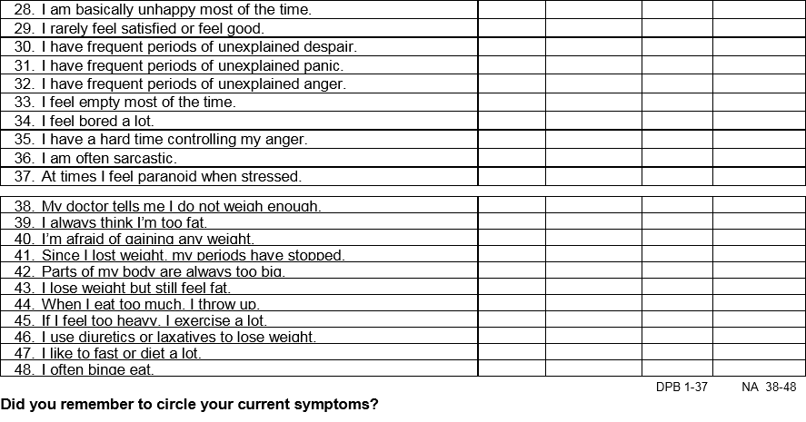
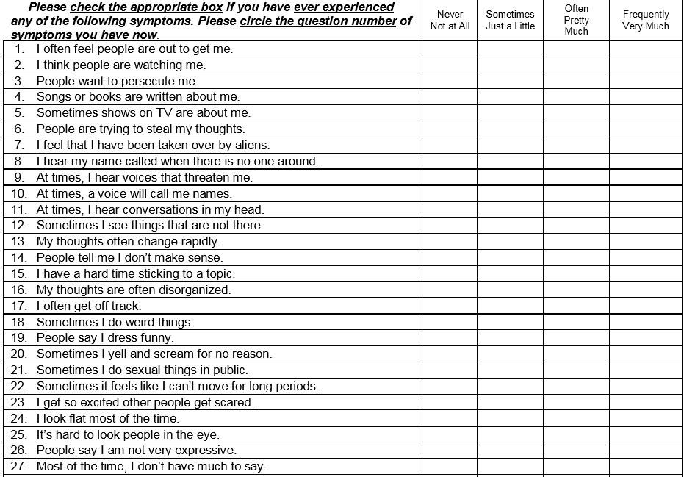
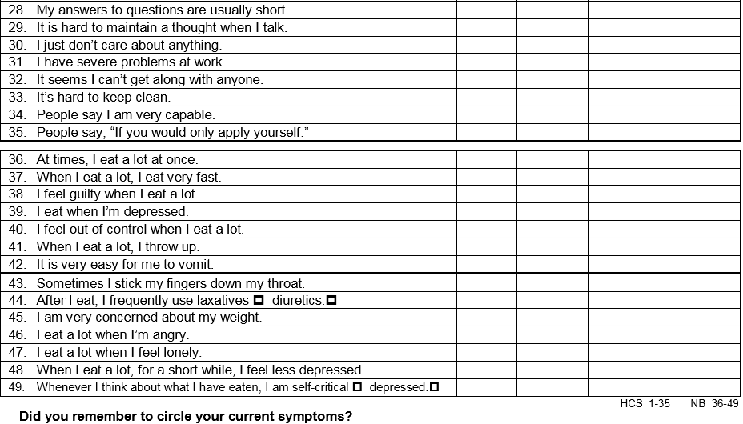

I certify that all information on the Adult Comprehensive History and Questionnaire Forms is true and correct to the best of my knowledge. I will notify Stephanie V. Straeter of any changes to my address, telephone numbers and any other relevant changes.

_____________________________________________ _______________________
Signature Date

_____________________________________________
Printed Name

